Tutorial: Creating and managing refueling alerts

Creating and managing refueling alerts
Refueling alerts allow you to monitor and receive notifications whenever a vehicle is refueled. By configuring alert conditions, you can ensure that the right people are informed whenever a refueling event occurs.
This helps fleet managers:
- Monitor refueling activity.
- Verify legitimate fuel fills.
- Improve visibility across the fleet.
- Respond quickly to important fuel events.
Creating a refueling alert
To create a new alert:
- Navigate to the Alerts tab.
- Select Fuel Level Refuel from the Alerts list.
- Click the + button to create a new alert.
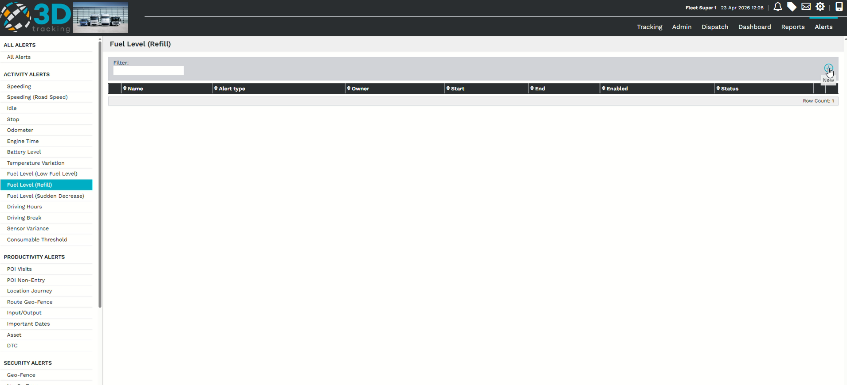
Configure the alert details
Complete the required alert information:
- Enter a descriptive Alert Name.
- Select the vehicle or vehicles the alert should apply to.
- Choose the calibrated fuel sensor for the selected vehicles.
Using the correct fuel sensor ensures that refueling events are detected accurately.
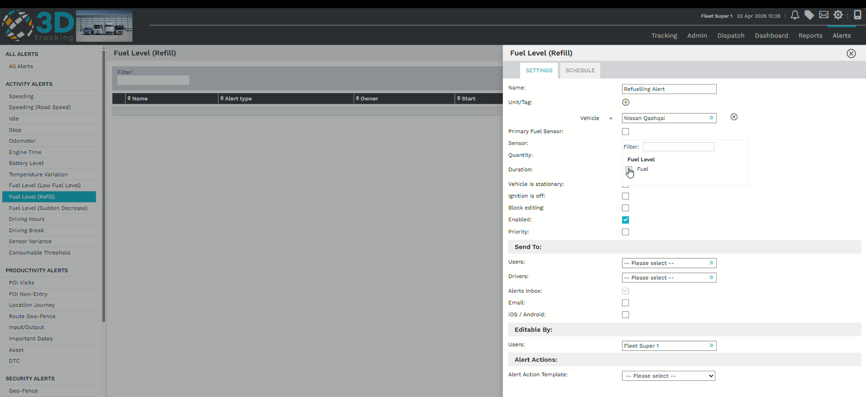
Configure alert conditions
Define when the alert should trigger by configuring the required conditions.
Set:
- The fuel quantity threshold.
- The duration for which the condition must be met.
You can also specify whether the vehicle must be stationary or whether the ignition should be on or off before the alert is triggered.
If these settings are left blank, the alert will trigger based only on the configured fuel quantity and duration.
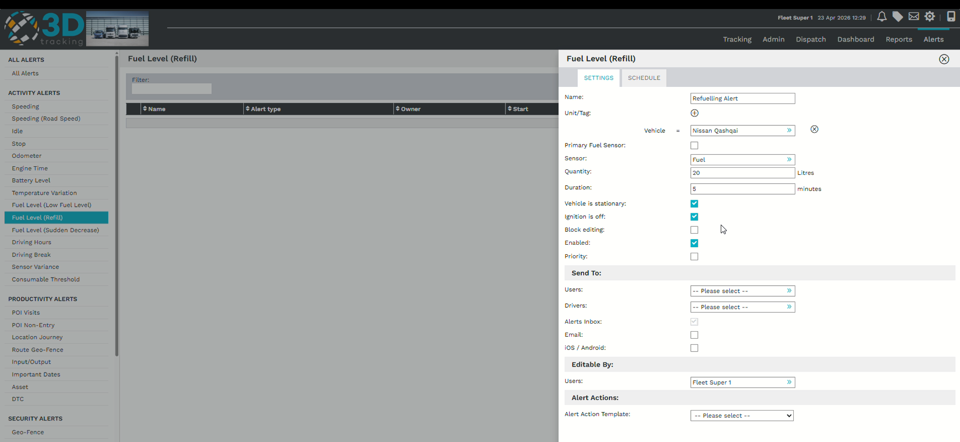
Configure alert notifications
Choose who should receive the alert when a refueling event occurs.
Configure:
- Alert priority.
- Platform users.
- Driver notifications (optional).
Notifications can be sent via:
- Email.
- Android.
- iOS.
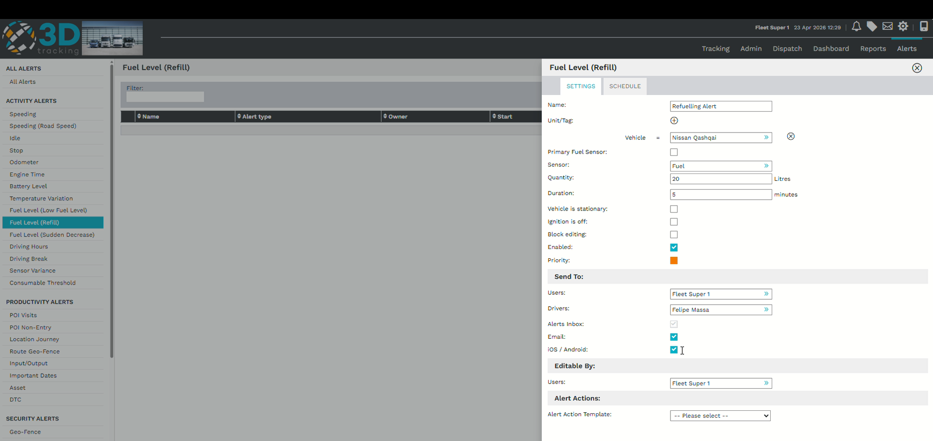
Schedule the alert
The schedule allows you to define:
- The start date.
- The end date.
Whether the alert is enabled.
Once the schedule has been configured, review the alert settings before saving.
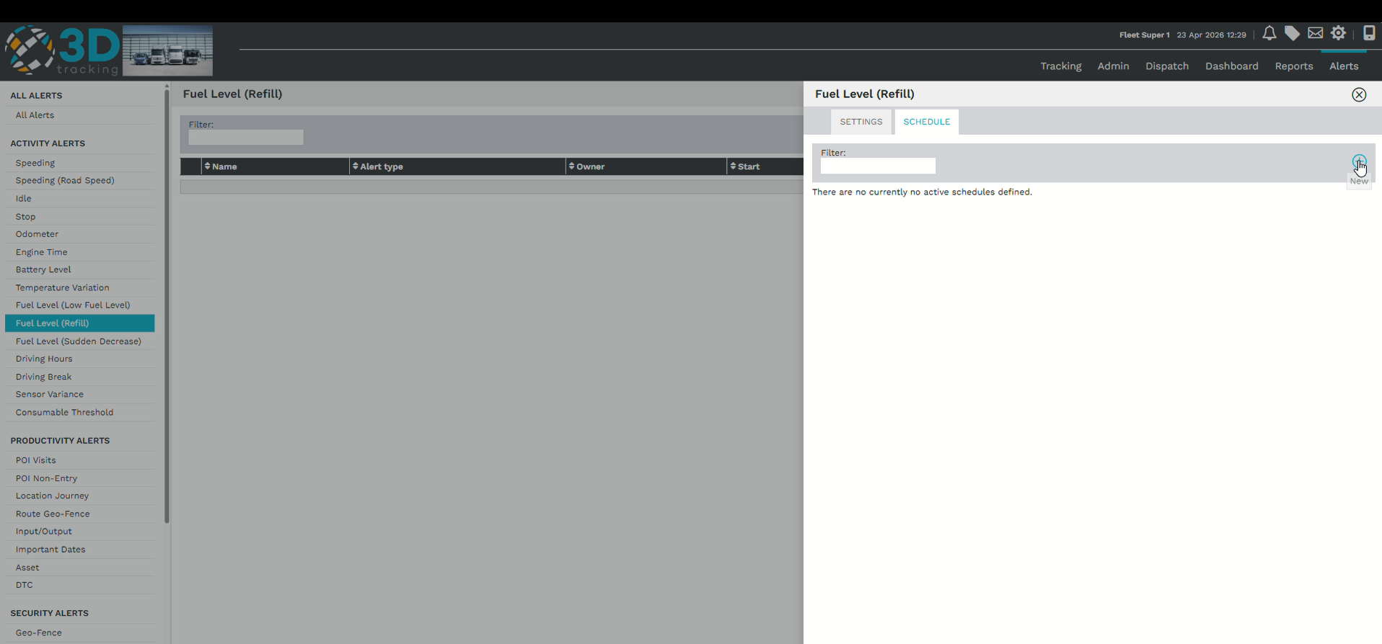
Saving the alert
After reviewing the alert configuration, click Save to activate the alert.
Once saved, the platform will monitor refueling events using the configured conditions and notify the selected recipients whenever the alert is triggered.
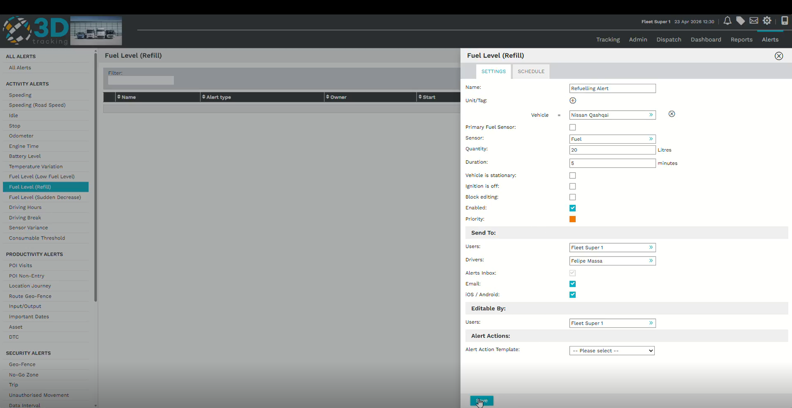
Summary
With 3Dtracking's Refueling Alert functionality, you can:
- Monitor vehicle refueling events.
- Notify users when refueling occurs.
- Configure alerts based on fuel thresholds.
- Improve fuel visibility across your fleet.

