Tutorial: Creating and managing low fuel level alerts

Creating and managing low fuel level alerts
Low fuel level alerts allow you to monitor vehicle fuel levels and receive notifications when fuel drops below a specified threshold. By configuring alert conditions, you can help prevent vehicles from running out of fuel and ensure timely refueling.
This helps fleet managers:
- Monitor fuel levels across the fleet.
- Receive early warnings of low fuel levels.
- Reduce vehicle downtime.
- Improve operational planning.
Creating a low fuel level alert
To create a new alert:
- Navigate to the Alerts tab.
- Select Fuel Level – Low Fuel Level from the Alerts list.
- Click the + button to create a new alert.
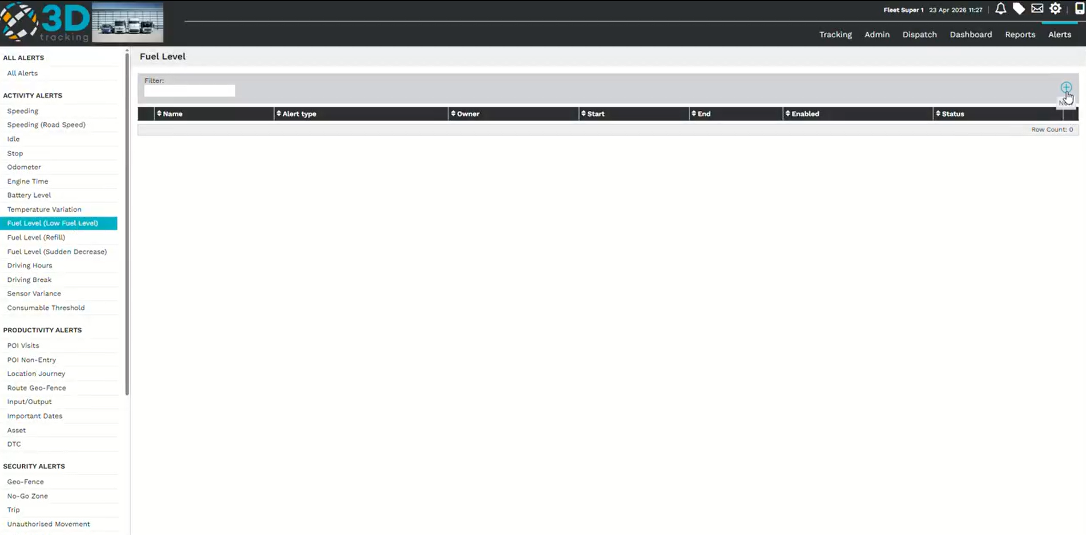

Configure the alert details
Complete the required alert information:
- Enter a descriptive Alert Name.
- Select the vehicle or vehicles the alert should apply to.
- Choose the appropriate fuel sensor for the selected vehicles.
If a primary sensor has already been assigned to the vehicle, it can be selected for the alert.
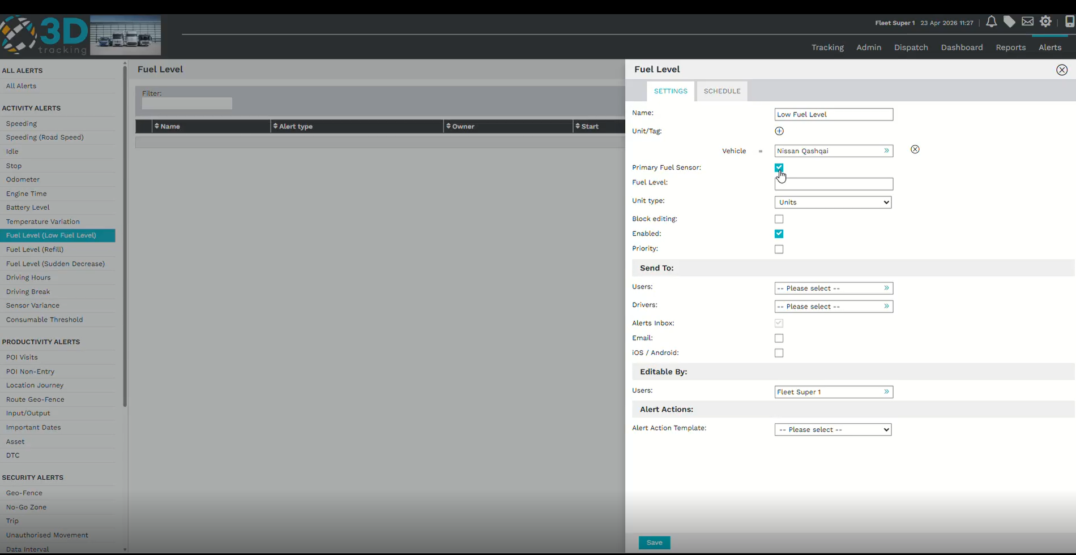
Configure alert conditions
Define when the alert should trigger by configuring the fuel threshold.
Set:
- The Low Threshold value.
- The Unit Type.
The Unit Type can be configured as:
- Units – The remaining fuel in liters.
- Percentage – The remaining fuel as a percentage of the tank capacity.
For example, setting the threshold to 10 Units will trigger the alert when approximately 10 liters of fuel remain.
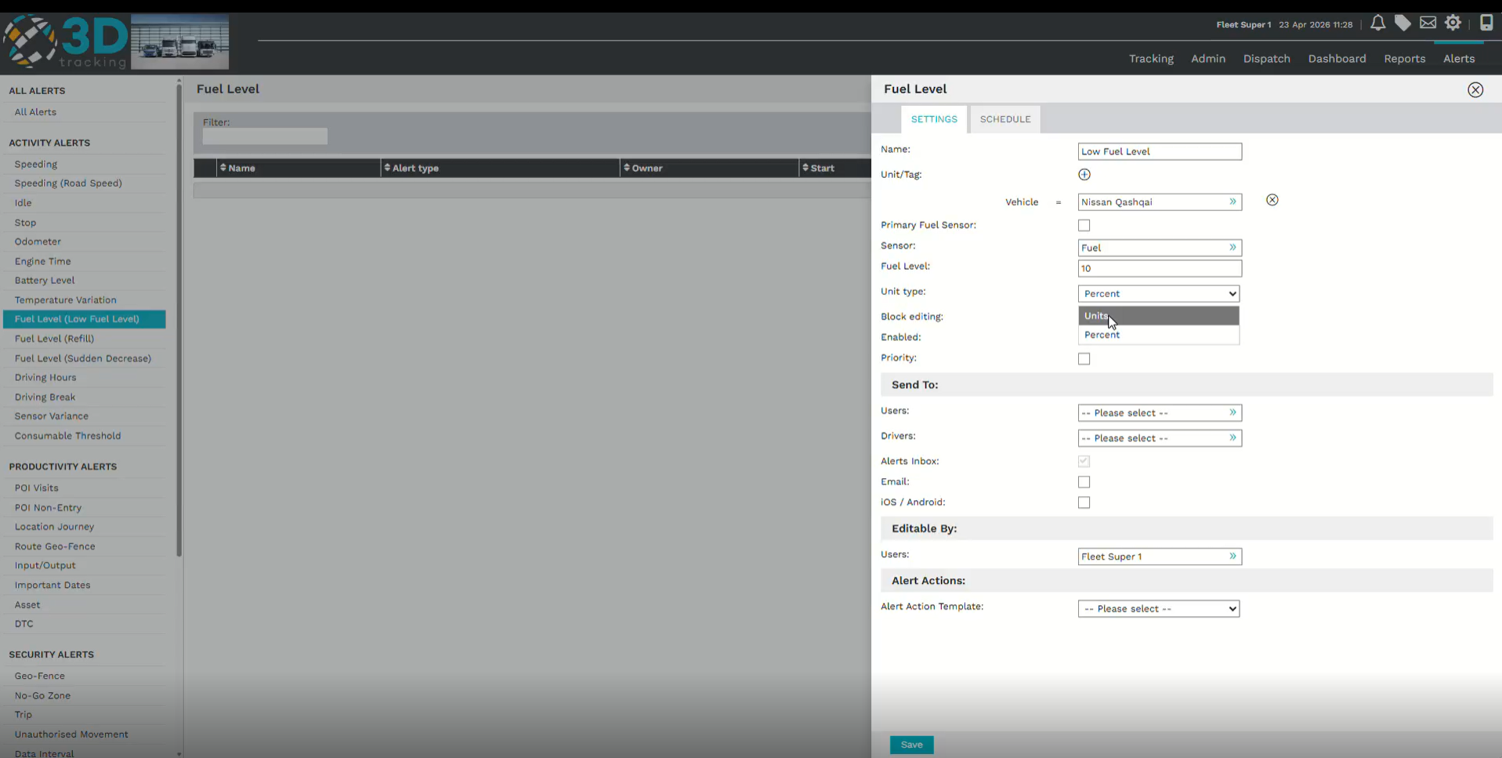
Configure alert notifications
Choose who should receive the alert when a low fuel event occurs.
Configure:
- Alert priority.
- Platform users.
- Driver notifications (optional).
Notifications can be sent via:
- Email.
- Android.
- iOS.
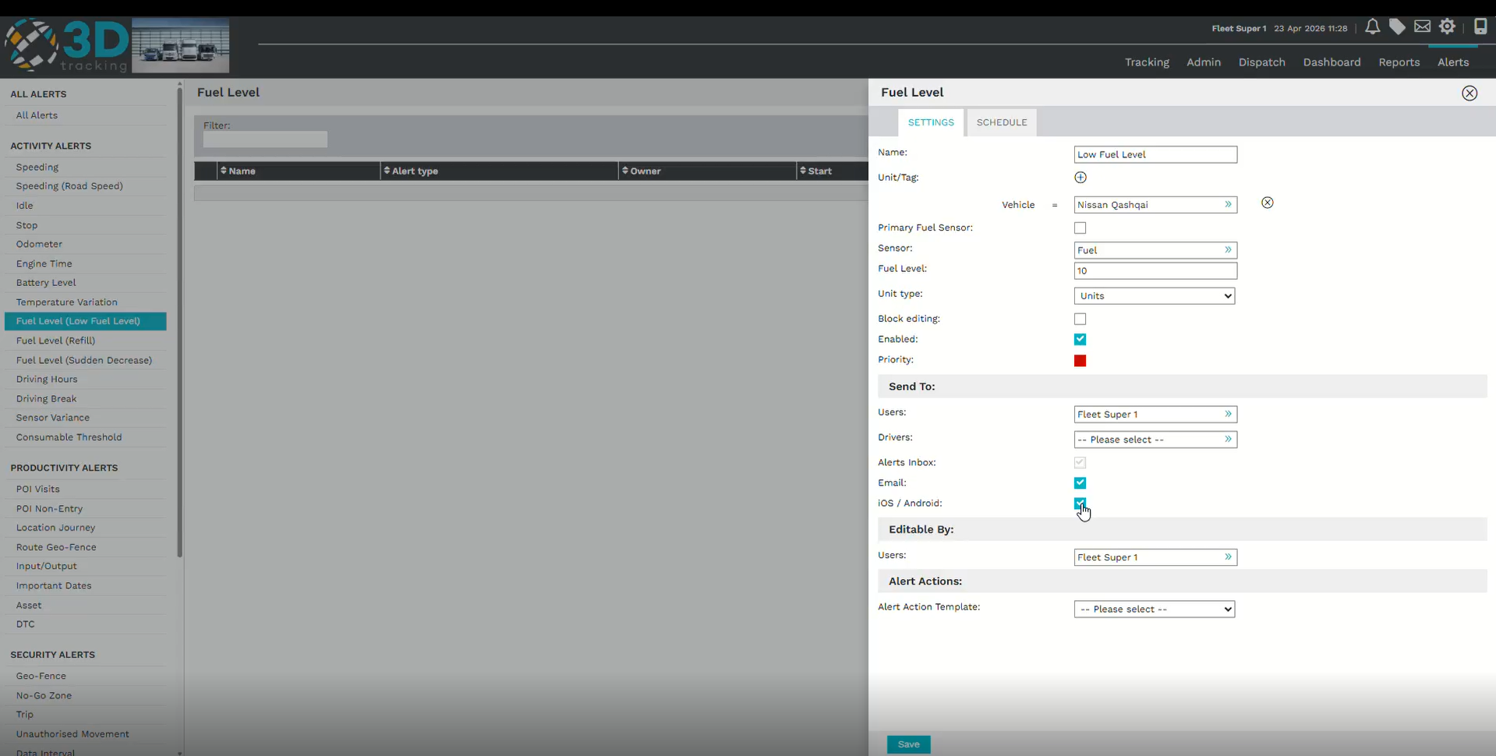
Schedule the alert
The schedule allows you to define:
- The start date.
- The end date.
Whether the alert is enabled.
Once the schedule has been configured, review the alert settings before saving.
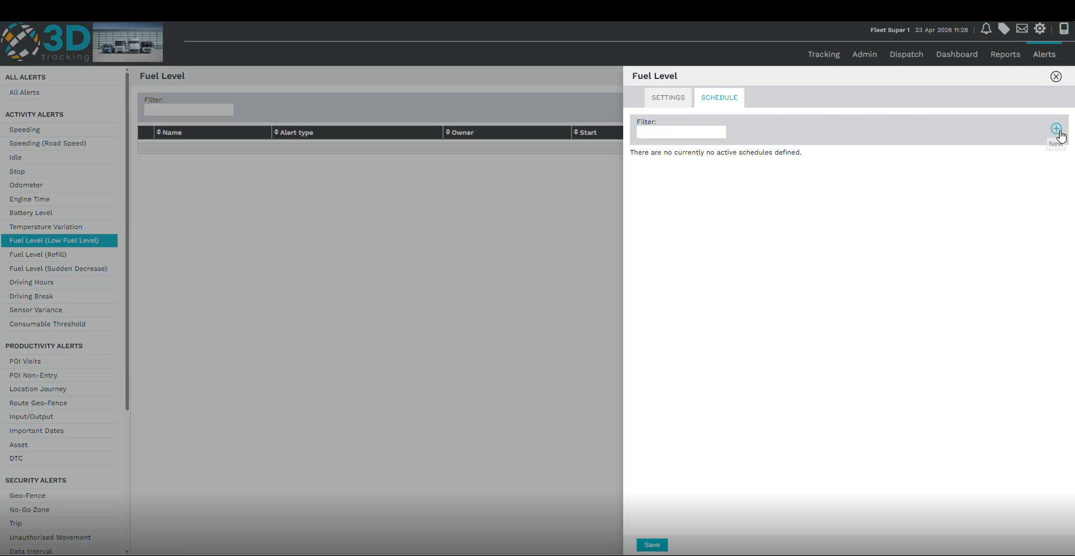
Saving the alert
After reviewing the alert configuration, click Save to activate the alert.
Once saved, the platform will monitor refueling events using the configured conditions and notify the selected recipients whenever the alert is triggered.
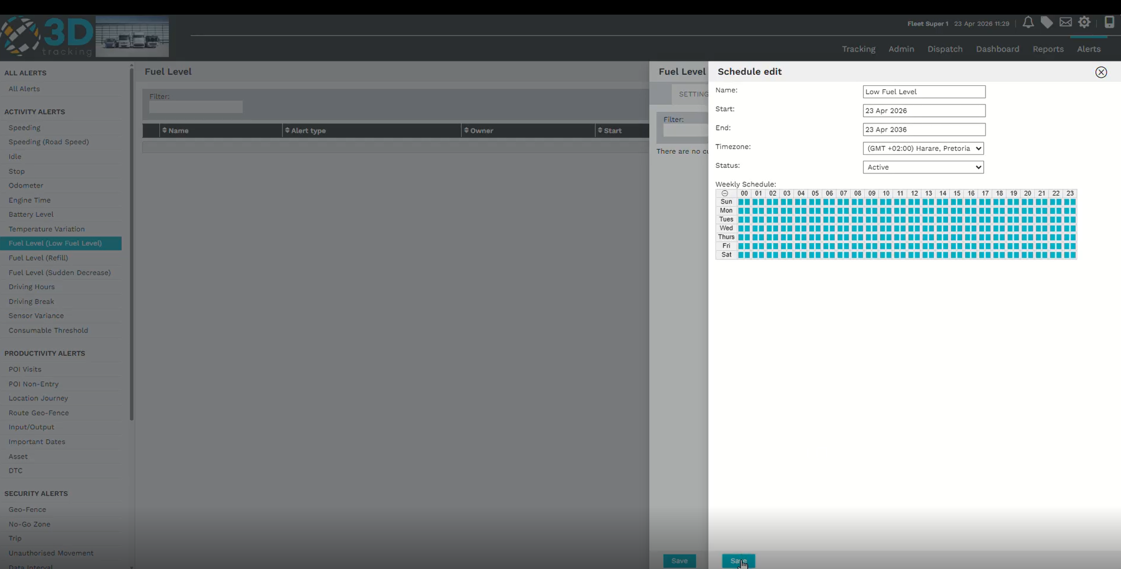
Summary
With 3Dtracking's low fuel level alert functionality, you can:
- Monitor vehicle fuel levels.
- Notify users when fuel reaches a specified threshold.
- Configure alerts using fuel units or percentage values.
- Improve fleet planning and reduce the risk of vehicles running out of fuel.

