Tutorial: Creating and managing sensor calibrations

Creating and managing sensor calibrations

Sensor calibration allows you to create custom calibrations for supported sensors, ensuring accurate data is captured and reported on the 3Dtracking platform. By configuring a sensor correctly, you can improve the accuracy of measurements such as fuel levels and ensure reliable reporting.

This helps fleet managers:

- Configure custom sensor calibrations.
- Improve the accuracy of sensor readings.
- Support reliable fuel monitoring and reporting.
- Standardize sensor configurations across vehicles.

Creating a new sensor calibration

To create a new sensor calibration:

- Navigate to Partner Admin.
- Select Sensor Calibration.
- Click the + button to create a new calibration.

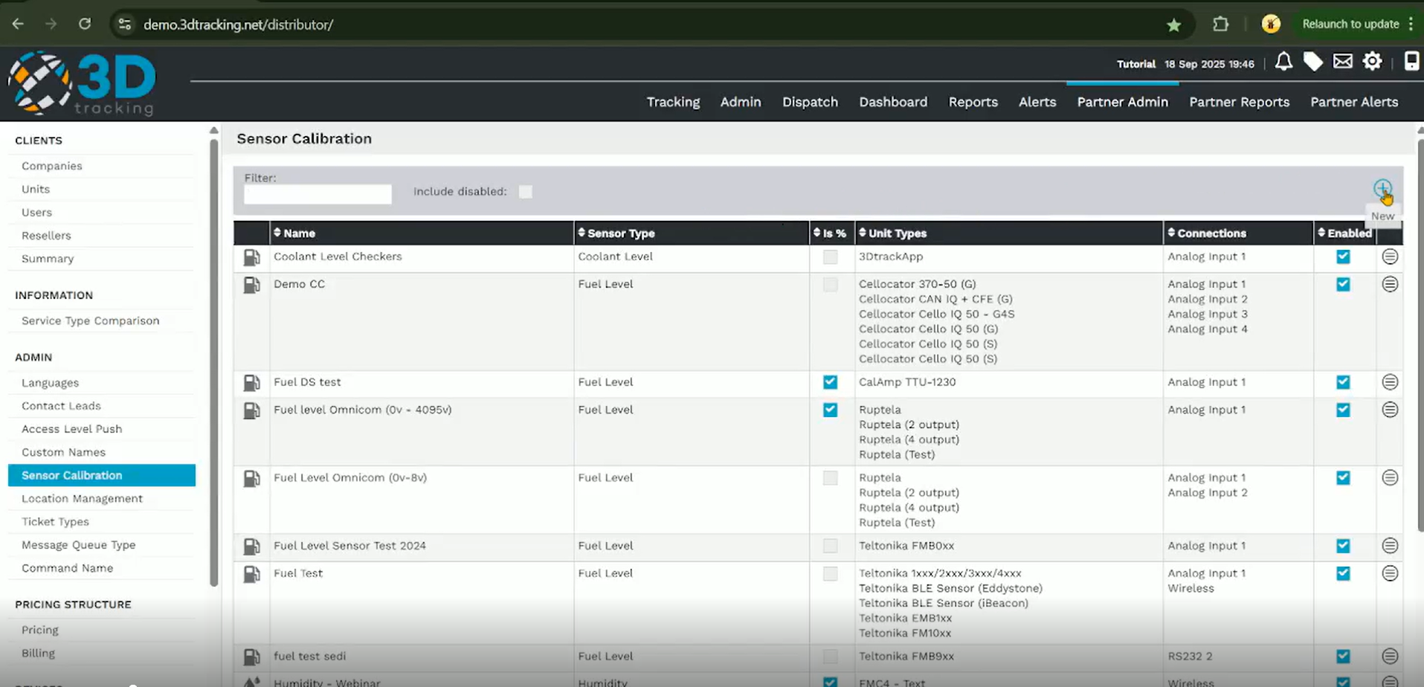

Configuring the sensor details

Complete the required sensor information.

Configure the following:

- Enter a descriptive sensor name.
- Select the sensor type.
- Choose the appropriate connection type.
- Select whether the calibration should display values as percentages, if required.

Available connection types may include wireless, CAN bus, analogue or digital inputs, depending on the sensor being configured.

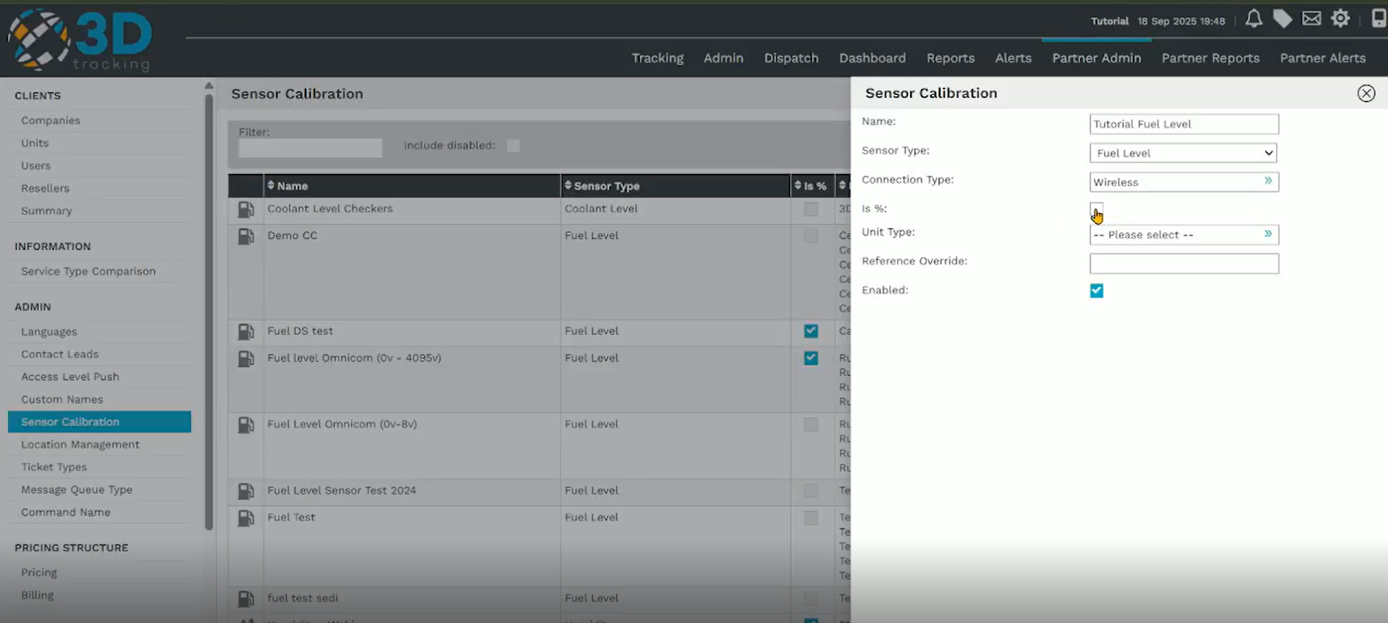

Selecting the device and reference

Next, configure the device that will use the sensor calibration.

Complete the following:

- Select the appropriate device model.
- Enter the reference override value supplied by the sensor.
- Click Save to create the calibration.
The reference override can be obtained from the sensor's recent data report or device configuration.

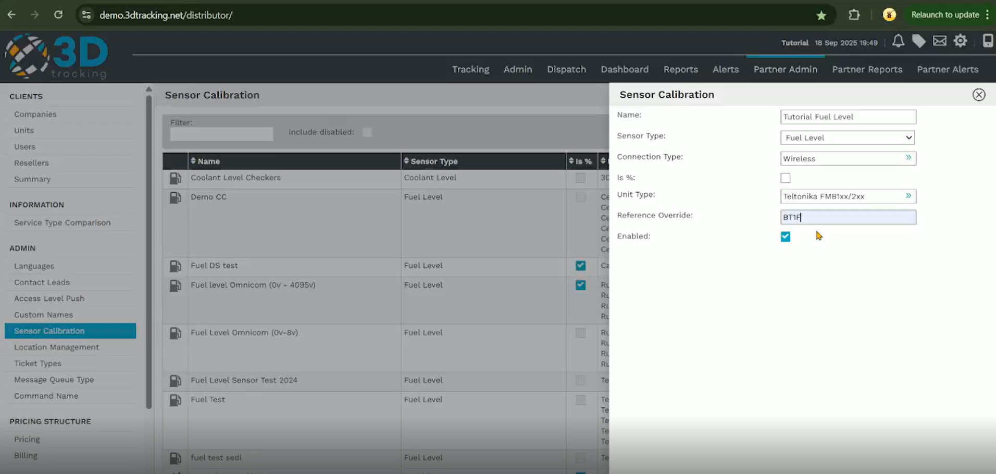

Creating the calibration table

After saving the calibration, create the calibration table that converts sensor readings into usable values.

Configure:

- The lower limit value.
- The upper limit value.
- The corresponding sensor readings and measured values.

For example, a sensor reading of 20 millivolts may correspond to 10 liters, while the upper limit represents the total capacity of the tank.

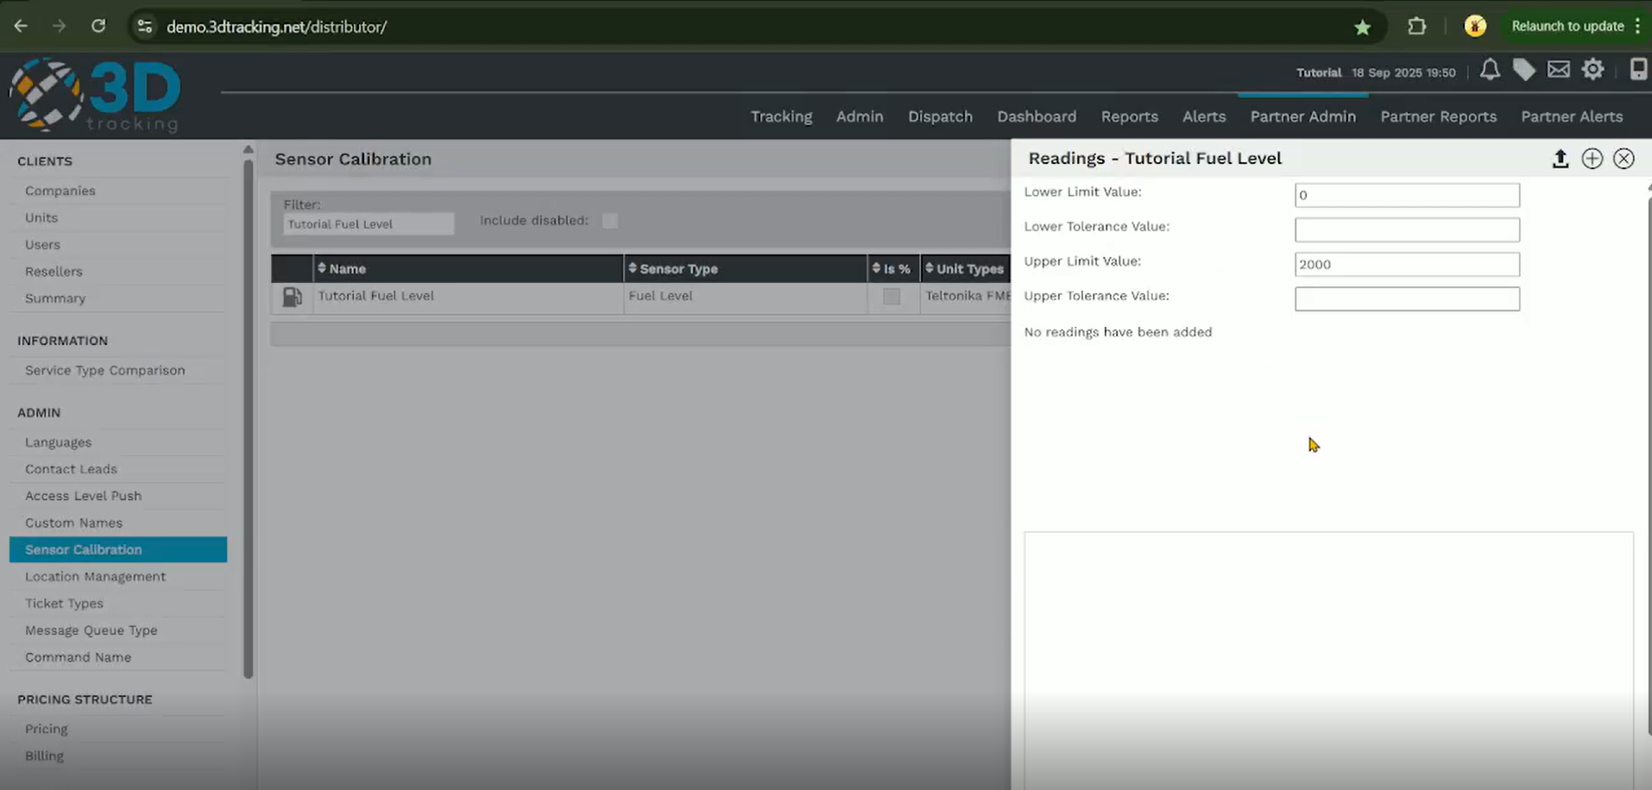

Importing a calibration table

If a calibration table has already been created, it can be imported instead of entering each value manually.

To import a calibration table:

- Click the Import button.
- Paste the calibration values into the import window.
- Click Add to populate the calibration table.
- Review the imported values.

The system automatically applies the imported values to the calibration table.

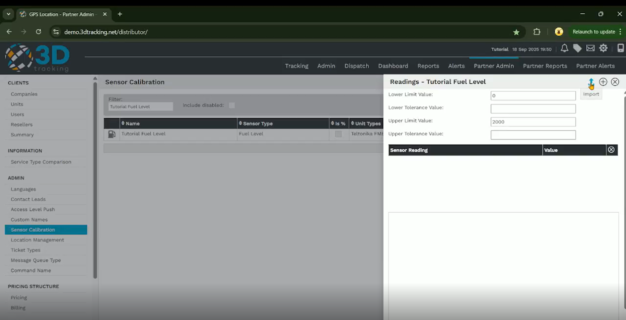

Saving the calibration

Before saving, review the calibration table to ensure all values have been entered correctly.

If duplicate values are detected, remove or correct them before saving the calibration.

Once complete, click Save.

The sensor calibration is now ready to be assigned to a compatible tracking unit.

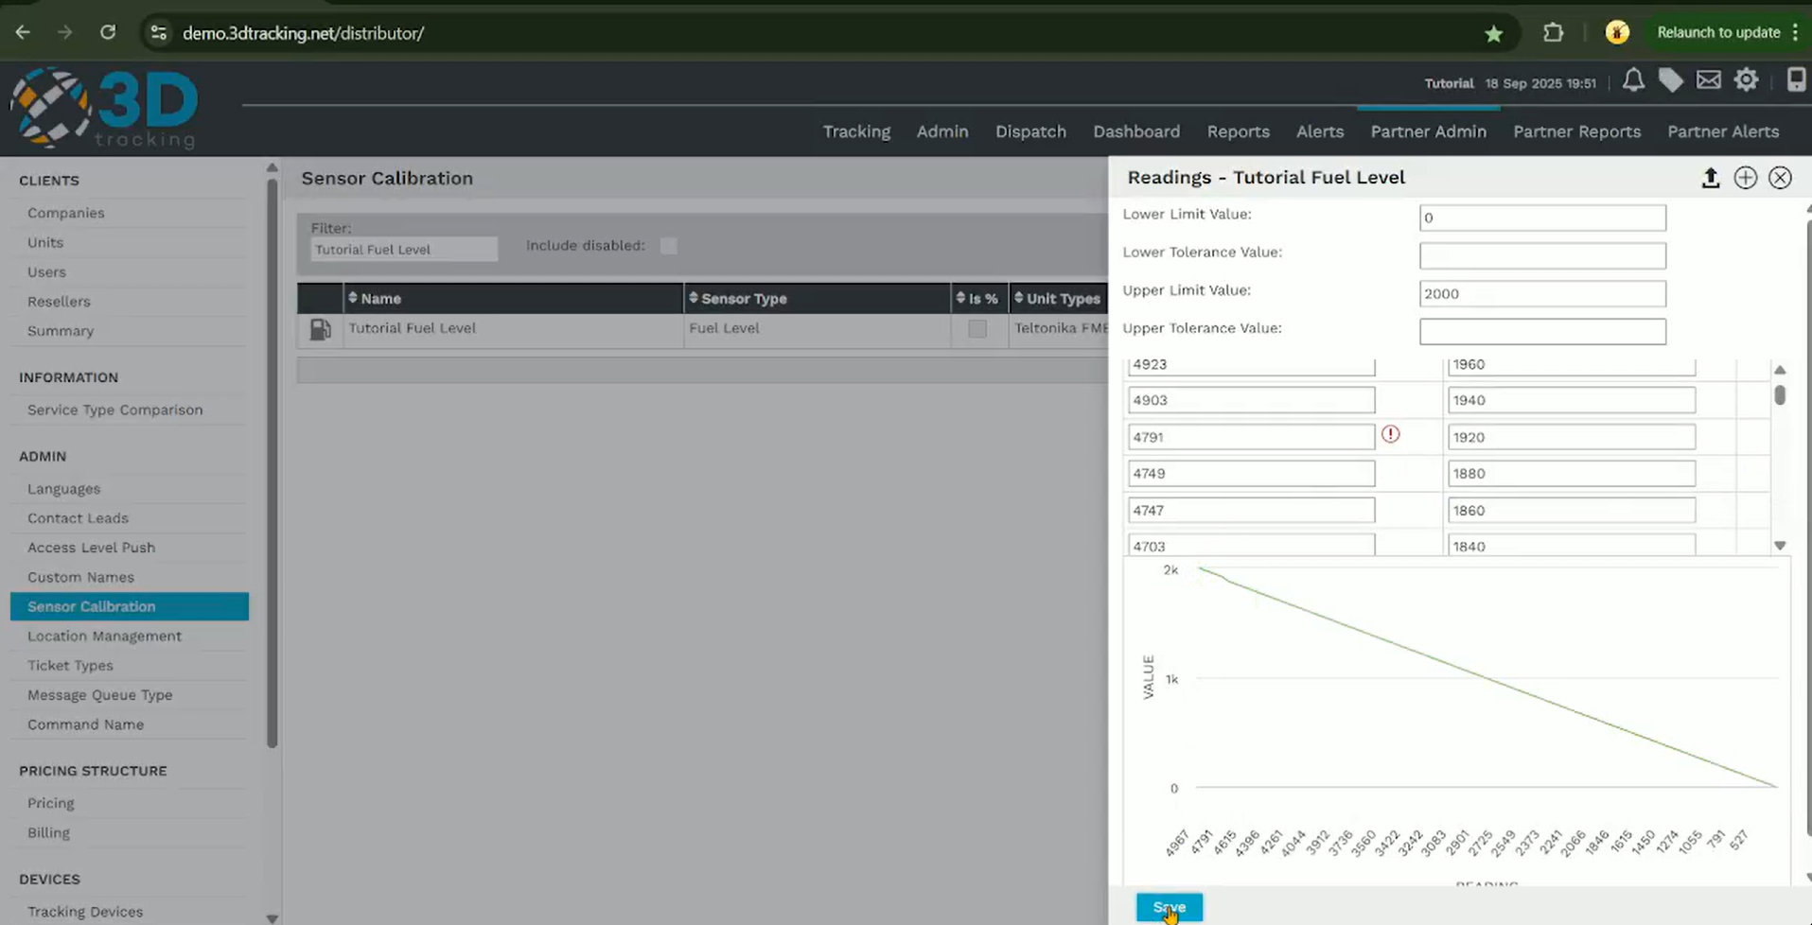

Summary

With 3Dtracking's sensor calibration functionality, you can:

- Create custom calibrations for supported sensors.
- Improve the accuracy of sensor measurements.
- Import or manually configure calibration tables.
- Prepare sensors for reliable reporting across your fleet.

