Tutorial: Creating and managing virtual geofence alerts

Creating and managing virtual geofence alerts
Virtual geofence alerts notify you when a vehicle moves beyond a defined area after the ignition has been switched off. By configuring a virtual geofence, you can detect unauthorized vehicle movement and improve fleet security.
This helps fleet managers:
- Detect unauthorized vehicle movement.
- Improve fleet security.
- Monitor vehicles after the ignition has been switched off.
- Respond quickly to unexpected vehicle activity.
Creating a virtual geofence alert
To create a new alert:
- Navigate to the Alerts tab.
- Expand Security Alerts.
- Select Virtual Geofence.
- Click the + button to create a new alert.
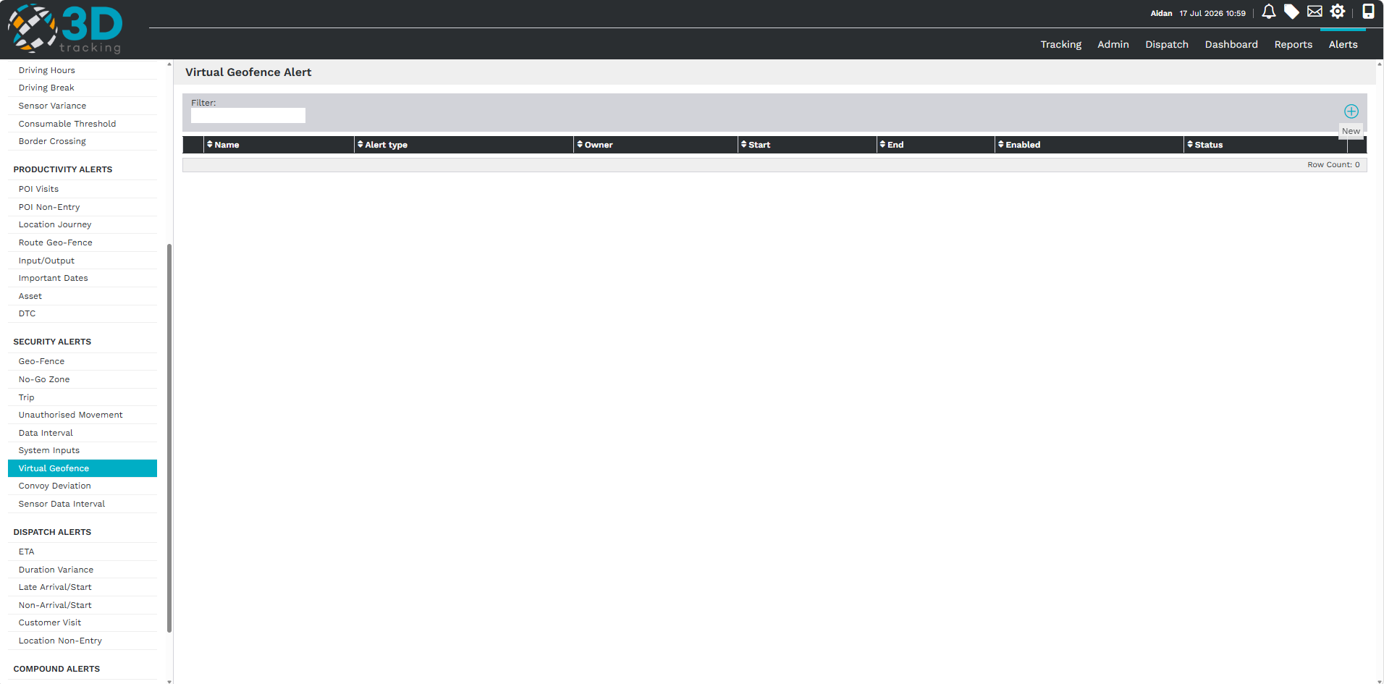

Configuring the alert details
Complete the required alert information.
Configure the following:
- Enter a descriptive alert name.
- Select the vehicle or vehicles the alert should apply to.
- Configure the alert parameters.
The virtual geofence alert monitors the distance a vehicle moves after the ignition has been switched off and remains outside the defined area for a specified period of time.
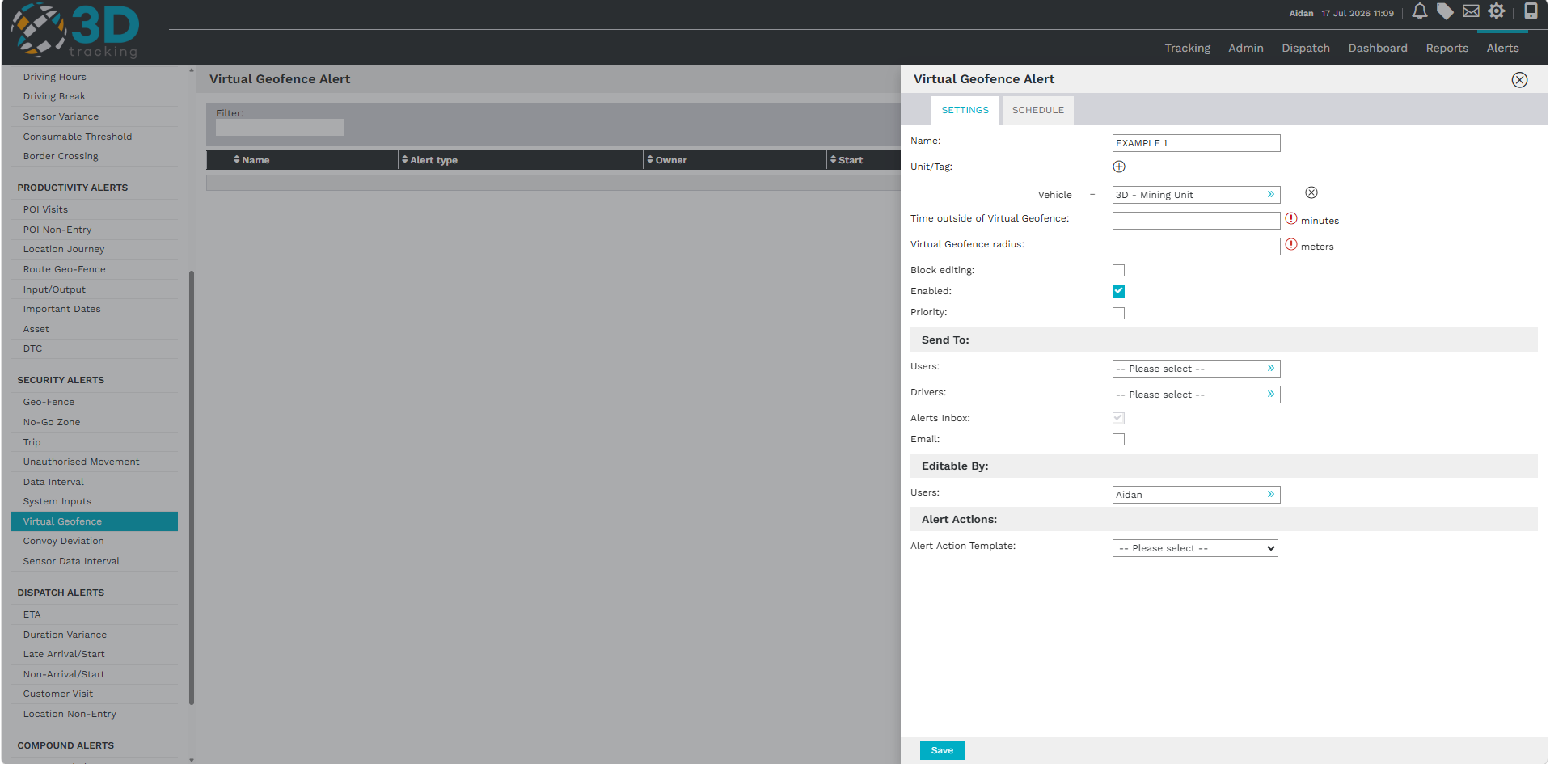
Configure alert conditions
Configure the conditions that determine when the alert is triggered.
Set:
- The time the vehicle must remain outside the geofence.
- The geofence radius.
The radius creates an invisible boundary around the location where the vehicle's ignition was switched off.
If the time is set to 0, the alert is triggered immediately when the vehicle moves outside the configured radius.
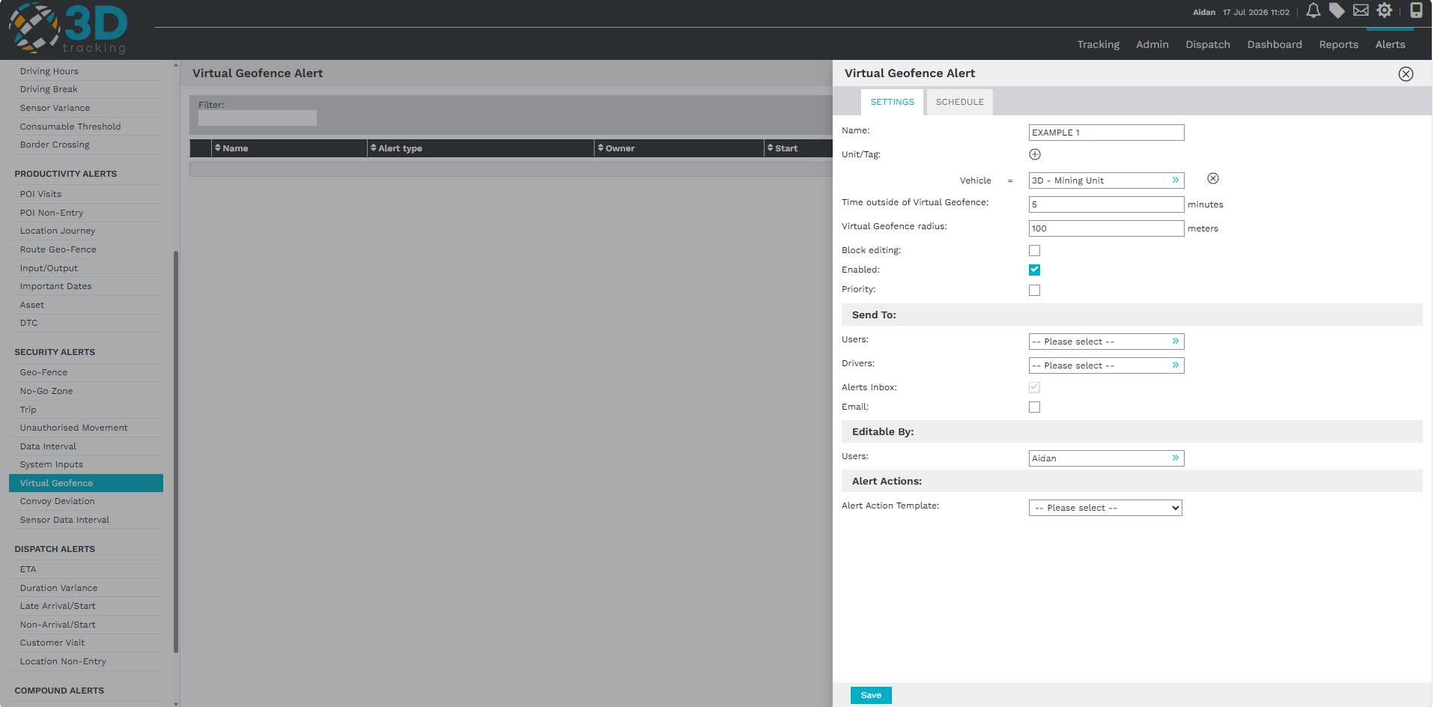
Configuring alert notifications
Choose who should receive the alert when the configured conditions are met.
Configure:
- Alert priority.
- Platform users.
Notifications can be sent via:
- SMS.
- Email.
- Mobile application.
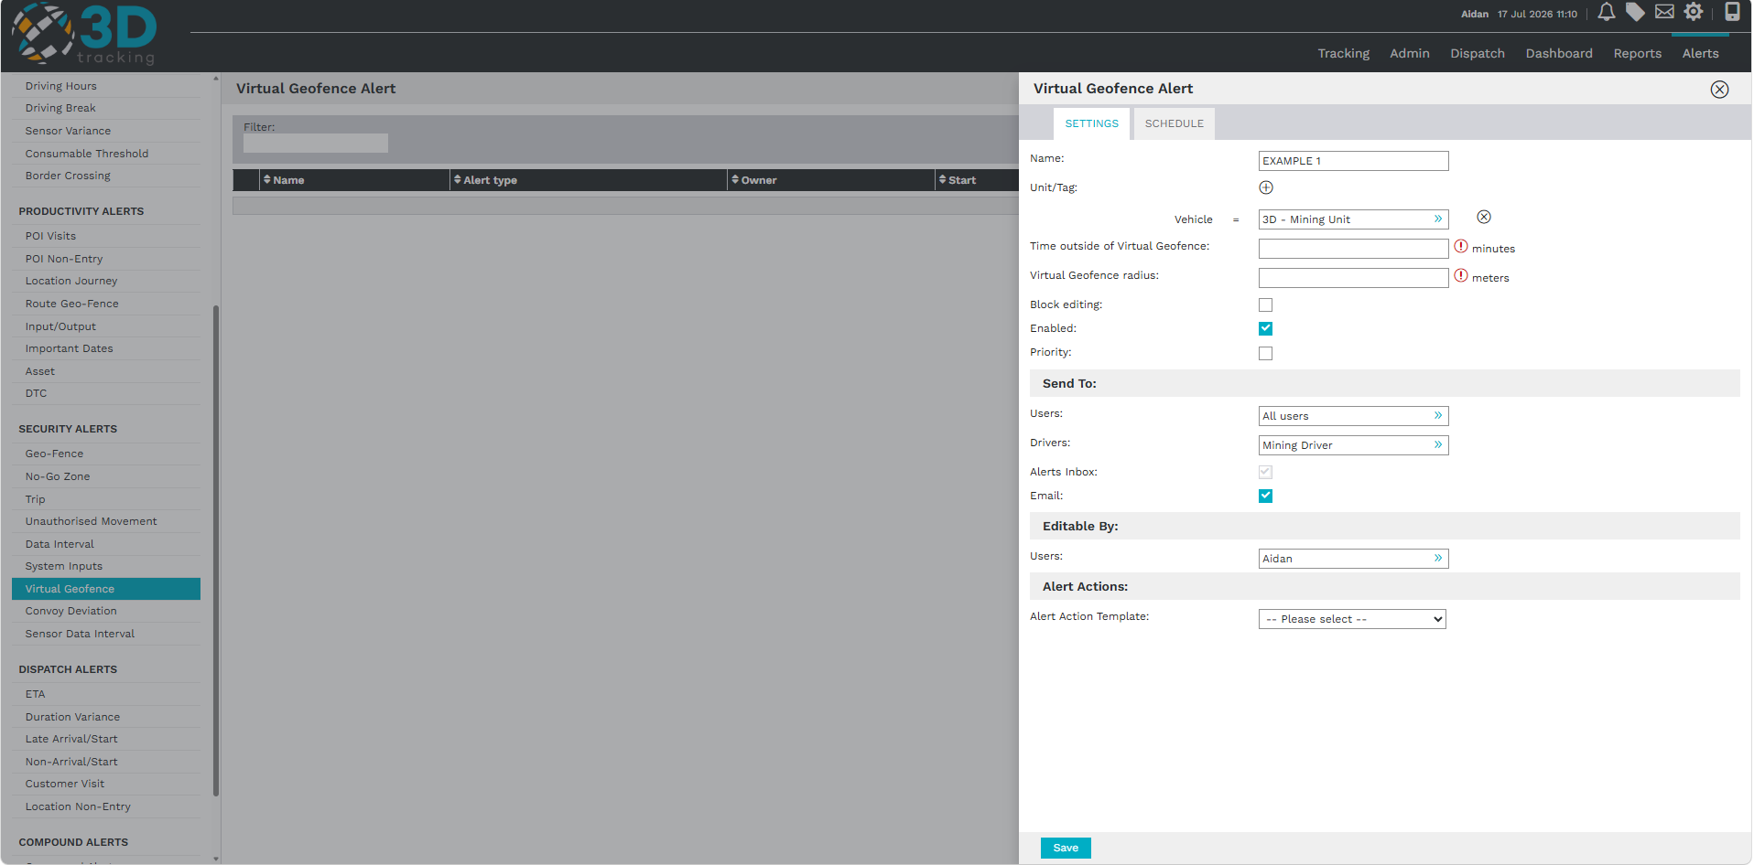
Scheduling the alert
Configure when the alert should be active.
The schedule allows you to define:
- The days the alert is active.
- The operating hours during which notifications should be sent.
To exclude operational hours, clear the relevant time blocks from the schedule. If you want to receive notifications at any time, ensure that all days and time periods remain selected.
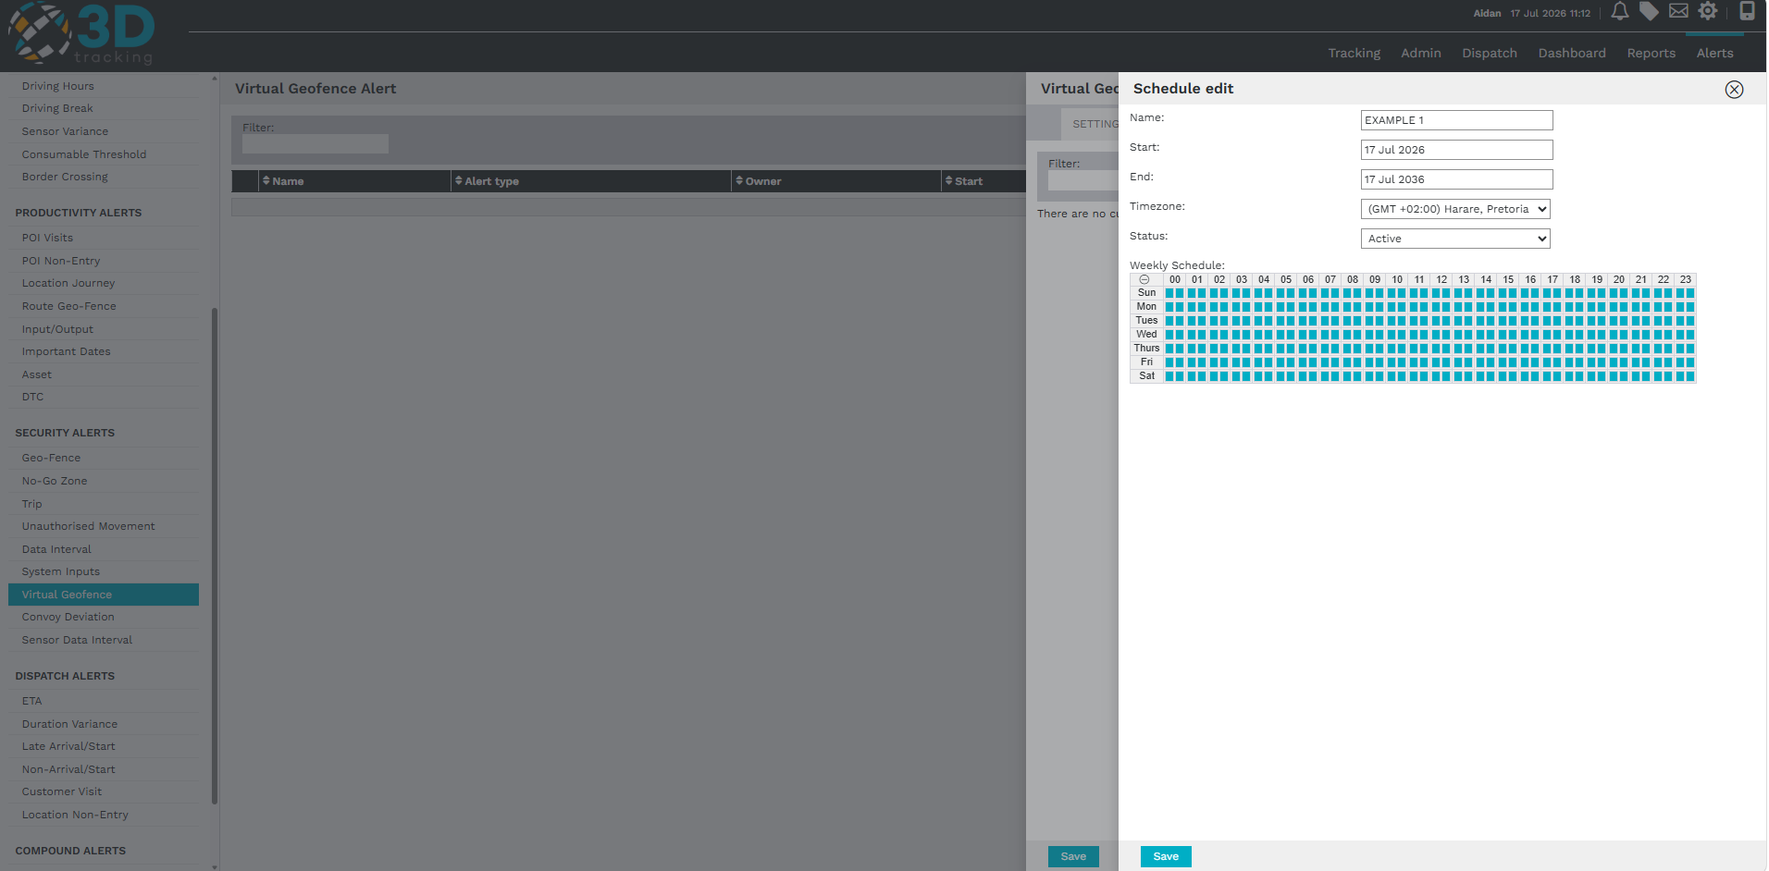
Saving the alert
After reviewing the alert configuration, click Save to activate the alert.
Once saved, the platform will monitor vehicle movement after the ignition has been switched off and notify the selected recipients whenever the configured geofence conditions are met.
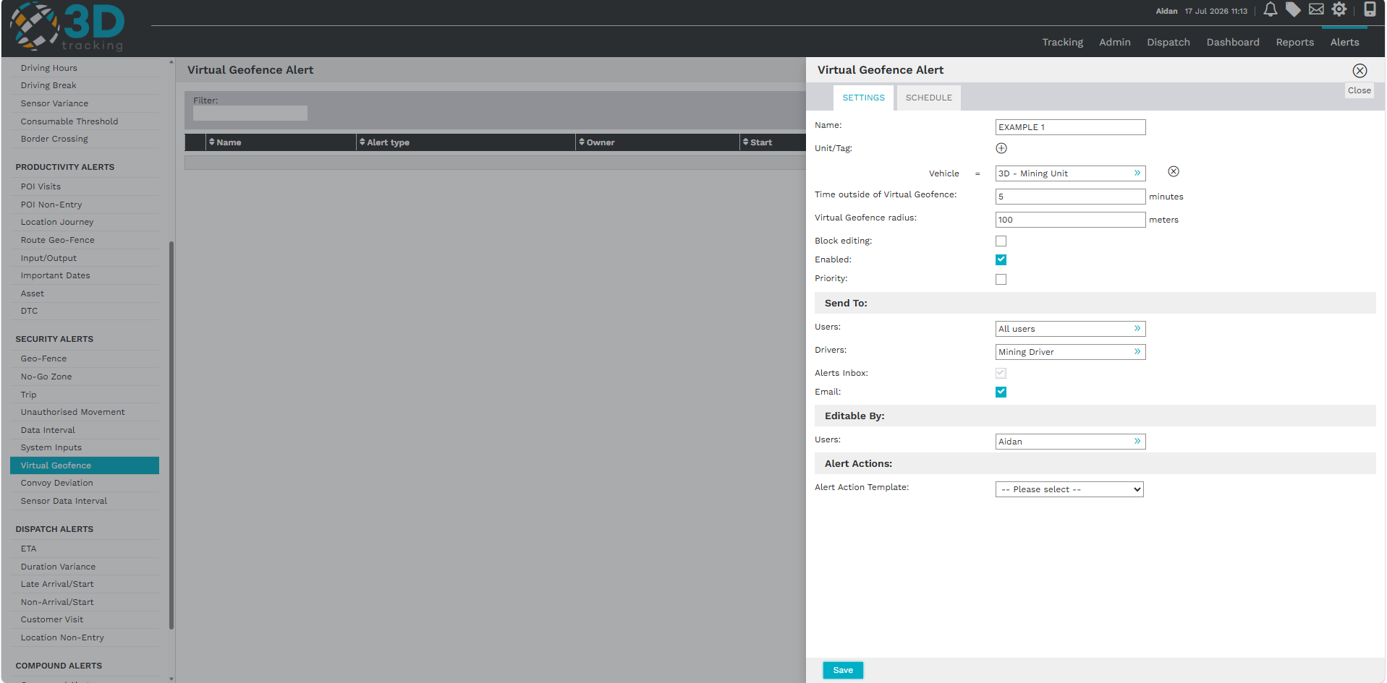
Summary
With 3Dtracking's virtual geofence alert functionality, you can:
- Monitor vehicle movement after the ignition has been switched off.
- Detect unauthorized movement outside a defined area.
- Configure alerts using customizable time and radius parameters.
- Improve fleet security and operational visibility.

