Tutorial:

Sign-On Options

Creating and Managing Users on the Platform

Creating and Managing Users on the Platform

Managing user access is essential for maintaining platform security and operational control. This section walks you through how to create users, define their access, and tailor their platform experience—all in a few easy steps.

Part 1: Creating a New User

To create a user:

- Navigate to the Admin tab and select User Management.
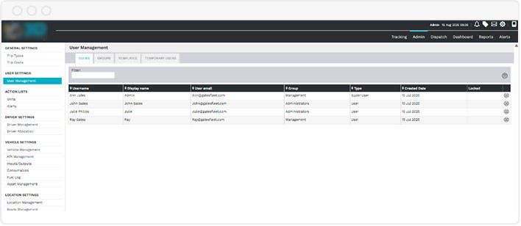

- On the right side, click the hamburger menu and choose New User.
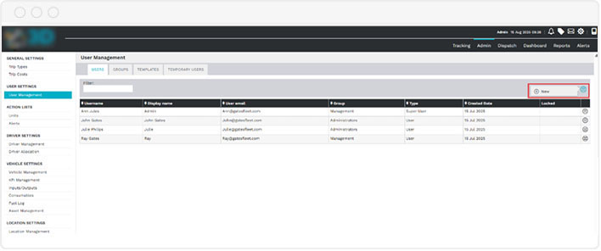

- Fill in the required fields on the New User Details screen:
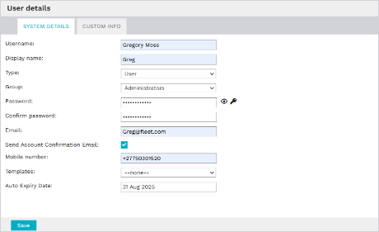
  - Name and Display Name
  - User Type:
    - Normal User – Standard access for most team members
    - Admin User – Broader access with admin rights
    - Super User – Full platform access
  - Group Assignment: Assign the user to a specific team or department.
  - Password, Email, and Mobile Number
  - Optional: Tick the box to send a confirmation email upon creation.
  - Optional: Select a Template to apply preconfigured access settings.
  - Optional: Set an Expiry Date if the account should be temporary.

Once all fields are completed, click Save to create the user account.

Part 2: Setting Feature Access

After saving the new user, you’ll be prompted to configure what they can do within the platform.
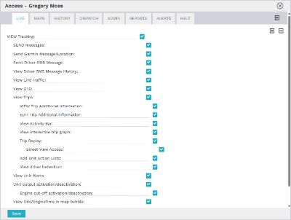

- Select access to key modules such as:
  - Maps
  - History
  - Dispatch
  - Admin
  - Reports
- For Reports, you can:
  - Choose individual reports.
  - Or grant access to all reports at once.
- Use the + button to quickly assign full access across all available features.

Click Save when finished.

Part 3: Configuring Group Access

Next, define which assets and map features the user can see:
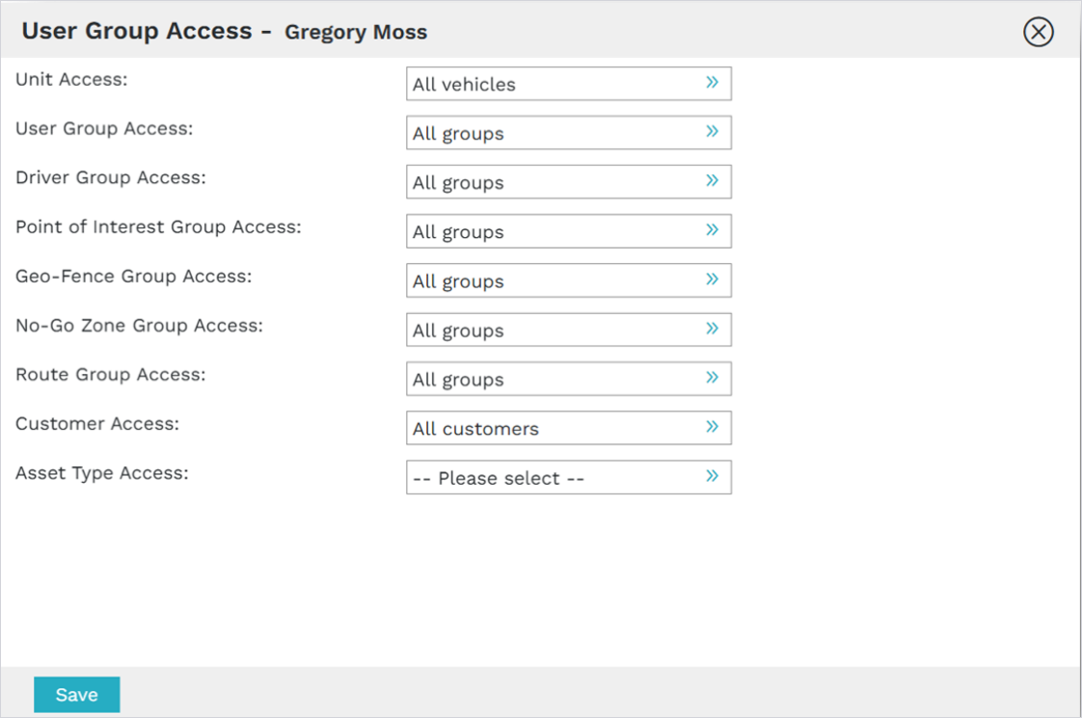

- In the Unit Group Access screen:
  - Assign access to all vehicles or restrict access to specific groups (e.g., delivery fleet only).
- Assign relevant User Groups and Driver Groups.
- Select which Points of Interest (POIs) and map locations are visible to this user.
Click Save once your selections are complete.

Part 4: Customizing User Preferences

Fine-tune the user experience to suit regional or operational needs:

- Return to User Management and search for the user by name.
- Go to the Preferences tab to set:
  - Preferred Distance and Speed Units.
  - Theme Color for the interface.
  - Default Start Screen (e.g., Tracking, Reports, etc.)
  - Map display settings and default filters for the Tracking tab.

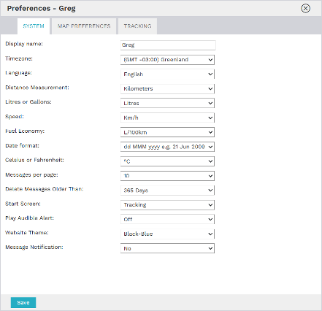

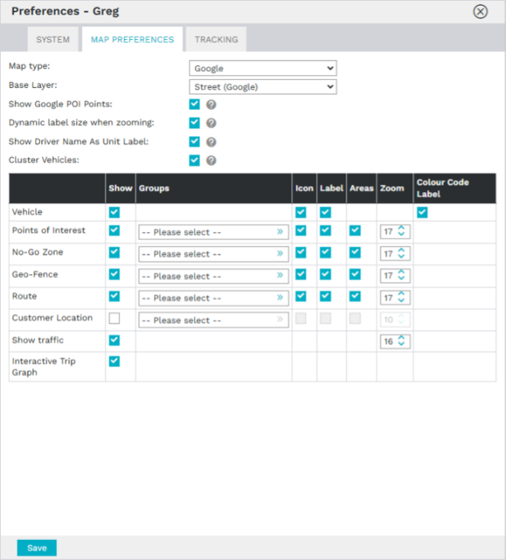
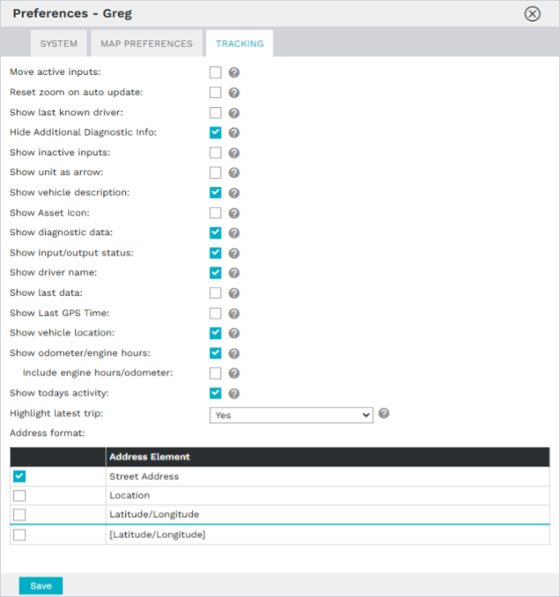

Click Save to apply preferences.

Part 5: Other Settings

- Return to User Management and search for the user by name.
- Click the hamburger menu next to their name to access options:
  - Change Password.
  - Send Account Confirmation Email.

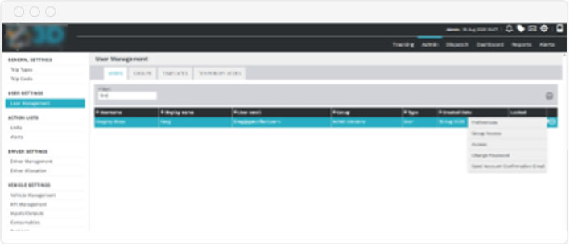

Summary

The User Management tools make it easy to:

- Create tailored user profiles.
- Define access with precision .
- Customize the user experience.
- Maintain security and operational clarity.

