Tutorial:
Fuel Monitoring Charts
How to view and interpret fuel monitoring charts

In this tutorial, we’ll walk you through how to view and interpret fuel monitoring charts on the 3Dtracking platform.

These tools are designed to make it easier to monitor fuel usage, identify unusual patterns, and stay on top of fuel costs.

Viewing Daily Fuel Levels
Start by heading to the Tracking tab.

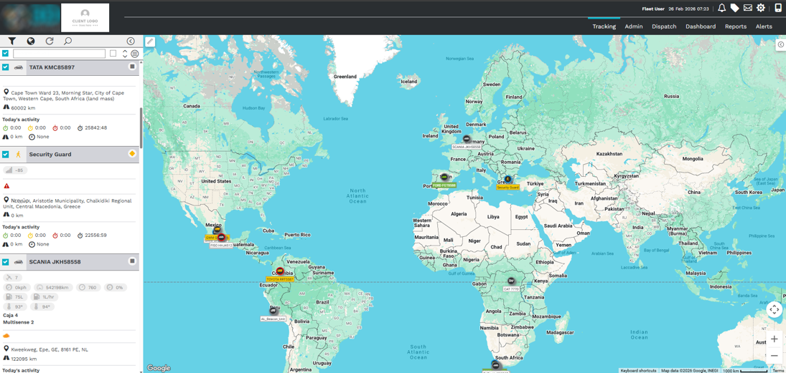

This takes you to the live view of your vehicles.
From here, select a vehicle to open the Unit Card.

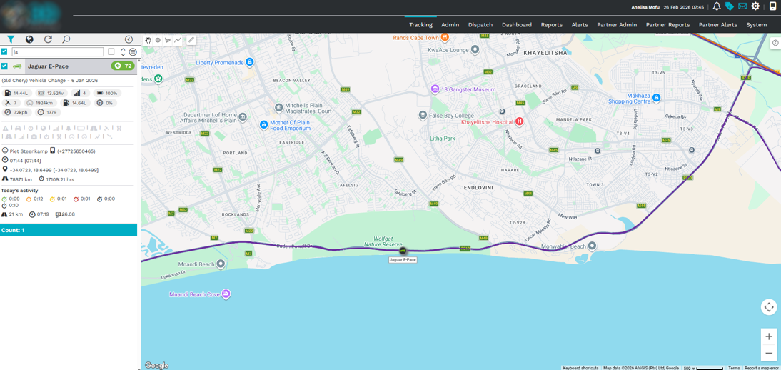

Then, click the fuel icon to open the Daily Fuel Level chart.

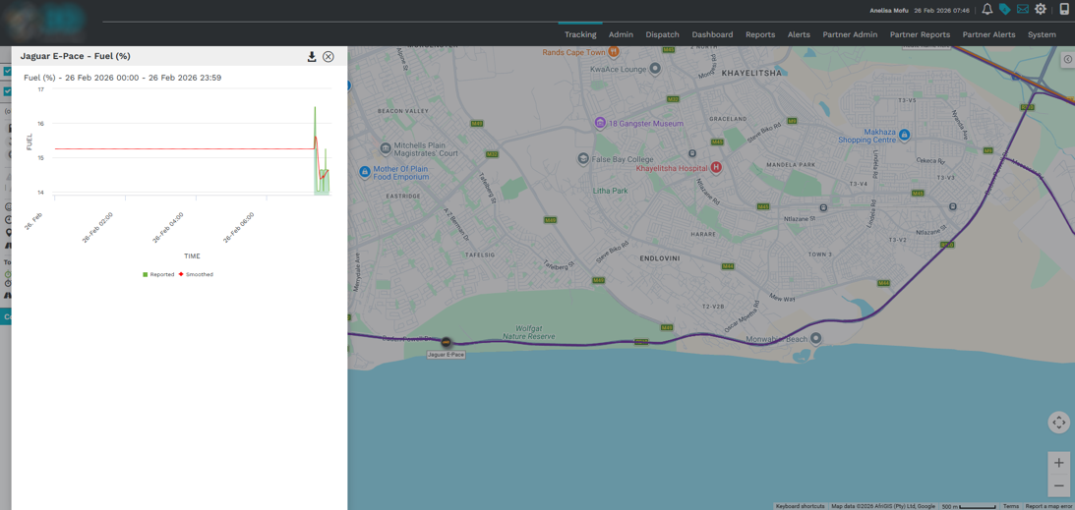

You’ll see a clear breakdown of fuel levels across the day—making it easier to track consumption in real time.

Viewing the Fuel Usage Chart
To access the Fuel Usage Chart, return to the Unit Card, and click the Filter icon.

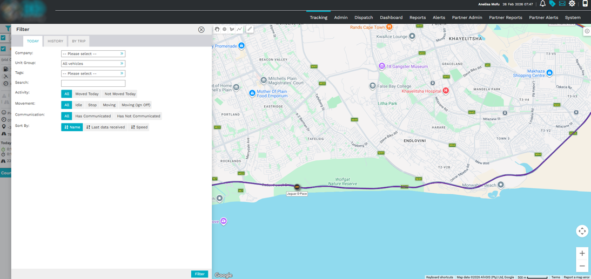

Use the date range selector to switch between current and historical trip data.

The fuel usage chart will appear below, giving you a detailed view of fuel consumption over time.

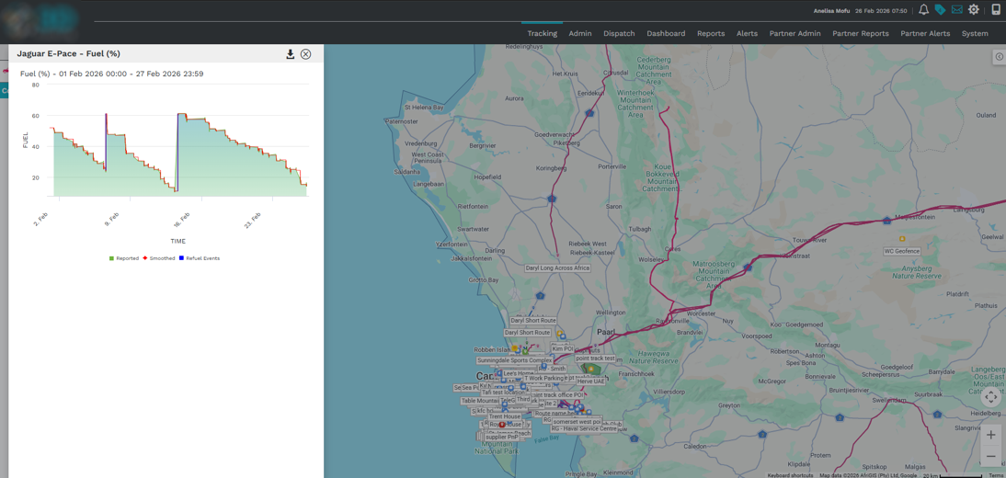

It’s designed to help you easily spot trends, identify irregularities, and analyze usage across different time frames.
Hover over any data point to see exact fuel readings for that moment.
And that’s how to access and read your fuel monitoring charts.
These easy-to-use tools give you real-time visibility and deeper insight into how your fleet is using fuel—so you can make smarter, more efficient decisions.

