Tutorial:
How to change your password
How to change or reset your password

How to Change Your Password
This guide shows you three different ways to change or reset your password on the 3Dtracking platform—whether you're logged in, logged out, or an admin resetting for another user.

Method 1: Forgot Password (from Login Screen)

Use this method if you’ve forgotten your password and can’t log in.
- Go to the platform login screen
- Click on “Forgot your password?”

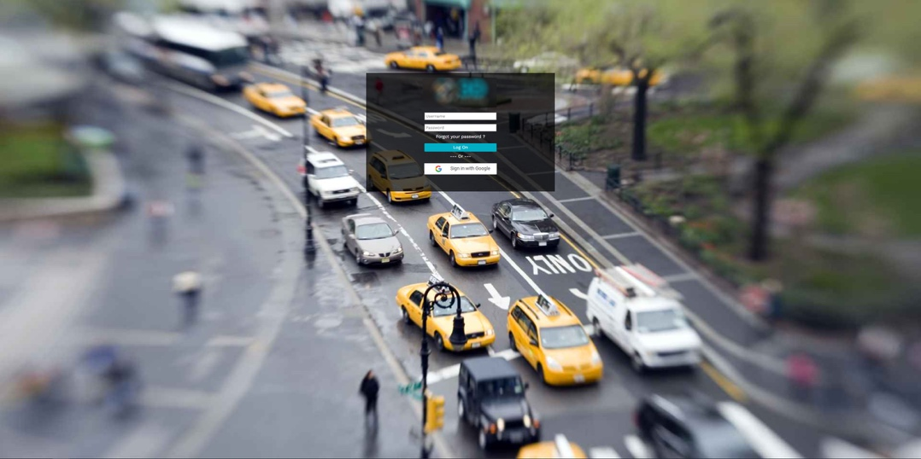

- On the next screen, enter your username or email and click Submit
- Check your inbox for a reset email from 3Dtracking
- Open the email and click the reset link



- You’ll be taken back to the login screen
- Enter your username, set a new password, confirm it, and click Change Password



You’re now logged back in with your updated password.

Method 2: Change Password from User Settings (Logged In Users)

Use this method if you're already logged into the platform and want to change your password manually.

- Hover over the Settings cog in the top-right corner
- Click User Settings

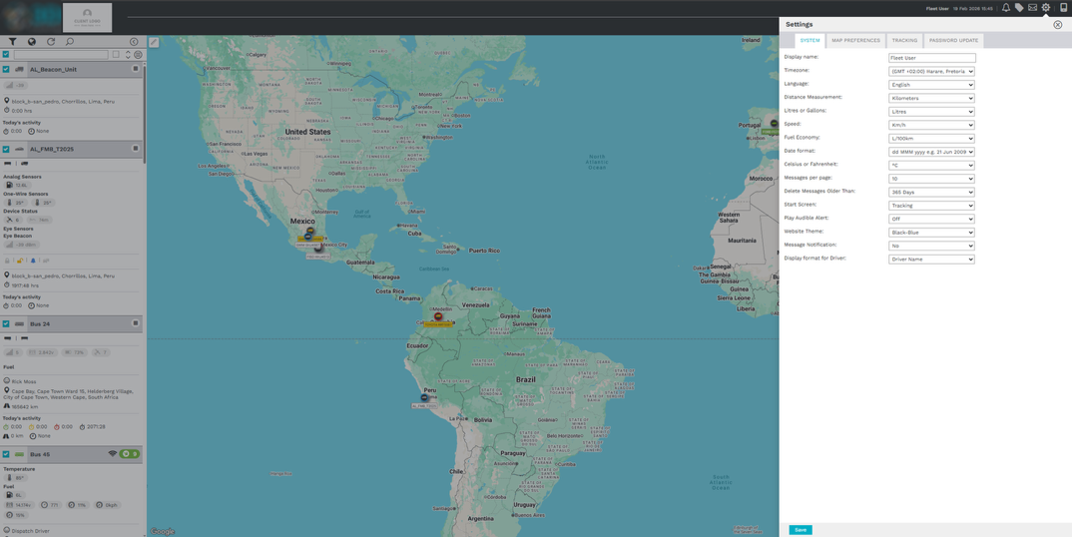

In the settings menu, click the “Password Update” tab
Enter your current password, then your new password, and confirm it

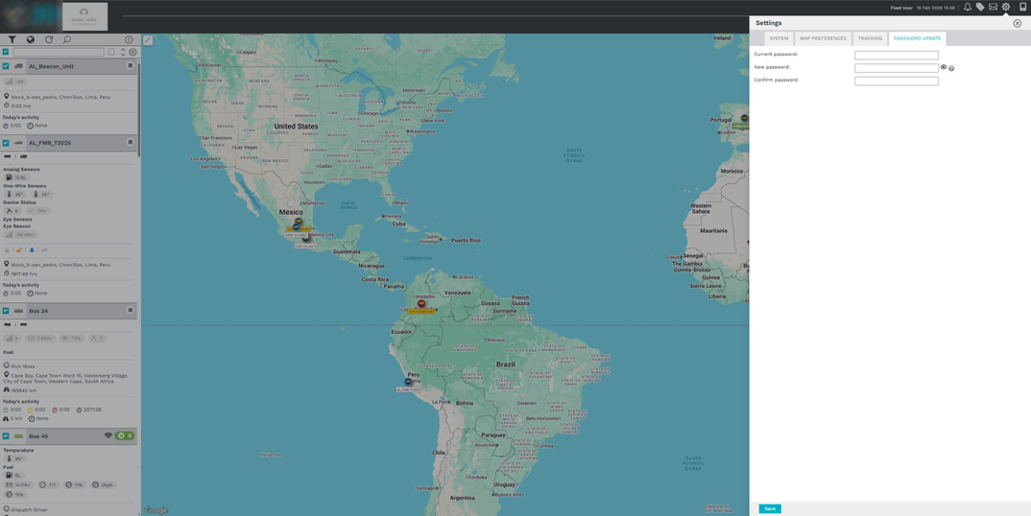

- Click Save

Your password is now updated.

Method 3: Admin-Initiated Password Reset (for Admin Users)

Admins can reset passwords for themselves or other users directly from the Admin panel.

- Navigate to the Admin tab
- Select User Management

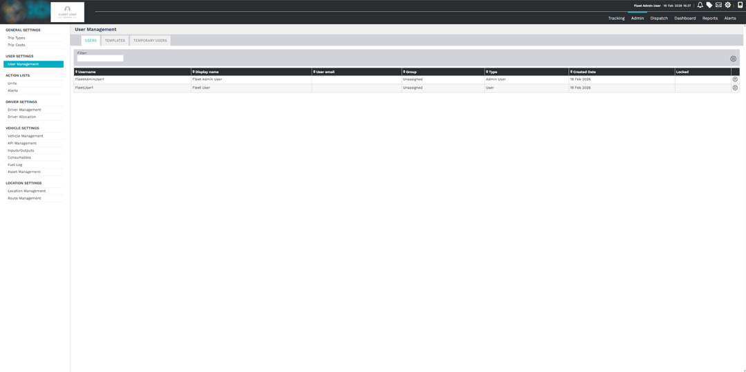

- Find the relevant user in the list (this could be yourself or another user)
- Click the hamburger menu next to their name
- Choose Change Password

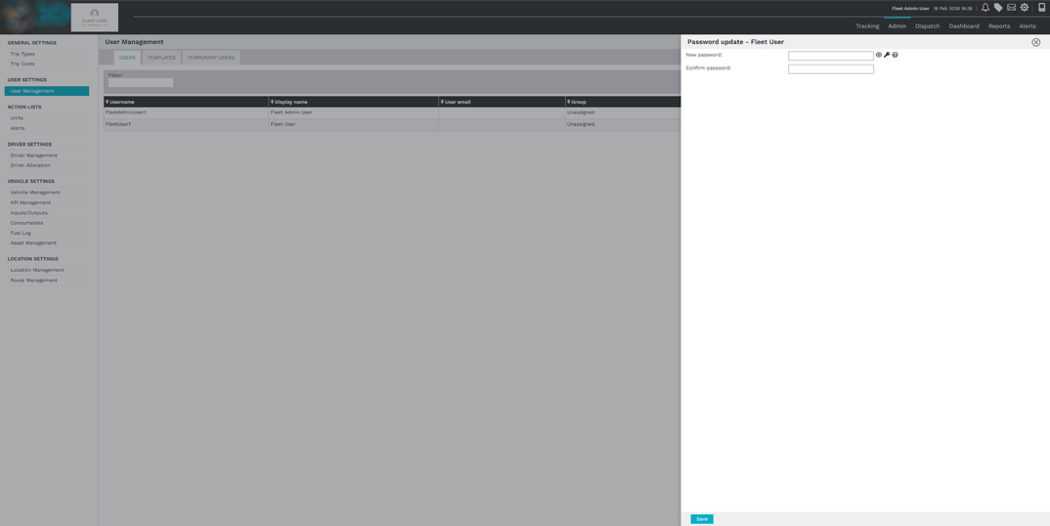

- Enter a new password, confirm it, and click Save

The password has now been updated.

Best Practices

- Use strong, unique passwords for security
- Update your password regularly, especially if you suspect unauthorized access
- Admins should only reset passwords for users when necessary

