Tutorial:
How to Generate and Schedule Reports

How to Generate and Schedule Reports

This guide walks you through how to generate Instant Reports and how to schedule recurring reports using the 3Dtracking platform's easy-to-use reporting tools.

Getting Started

To begin, click on the Reports tab.

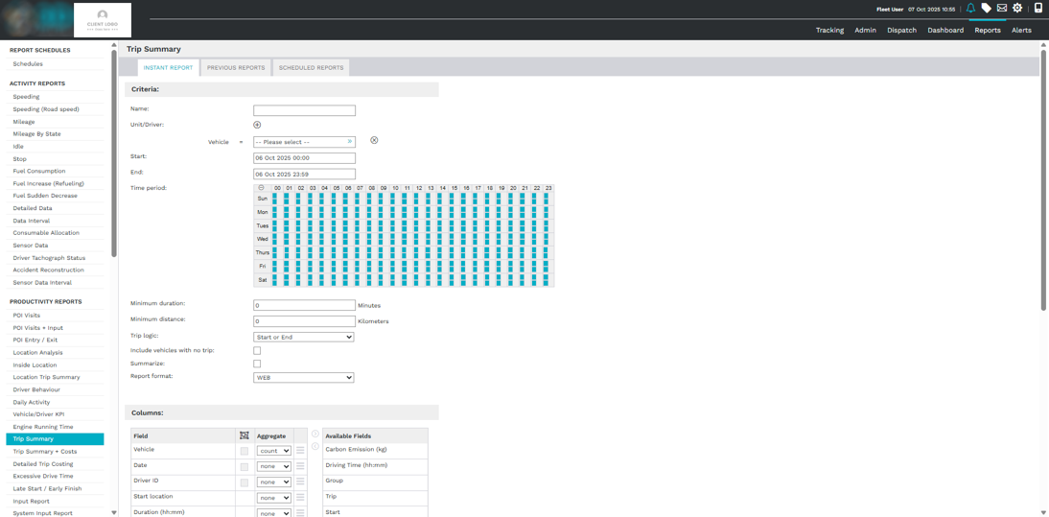

On the left-hand side, you’ll see a list of all the reports your user profile has access to. Every report on the platform gives you the option to either:
- Generate it instantly
- Or schedule it to run automatically

We’ll walk through both options using the Trip Summary Report as an example.

Instant Reports

Instant Reports let you generate real-time data at the click of a button.
This is ideal for getting quick insights into things like vehicle location, current speed, or trip activity.

Steps to Create an Instant Report:

- Select a report (e.g. Trip Summary Report)
- You’ll see three tabs:
  - Instant Report
  - Previous Reports
  - Scheduled Reports

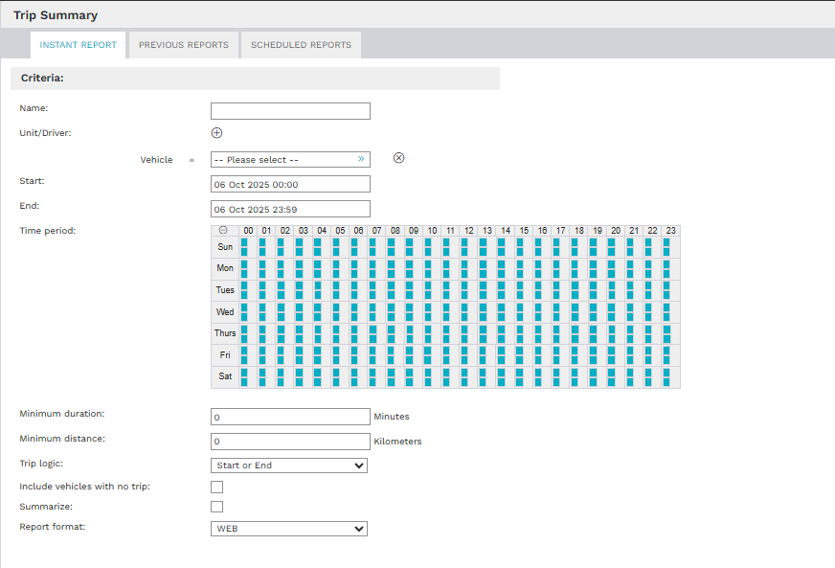

- In the Instant Report tab:
  - Enter a Report Name (e.g. Trip Summary – All)
  - Select a vehicle, a group, or all vehicles
  - Set the Date Range
  - Define a specific time period (e.g. to exclude after-hours trips)
  - Complete any required fields—for example:
    - Minimum Duration
    - Minimum Distance

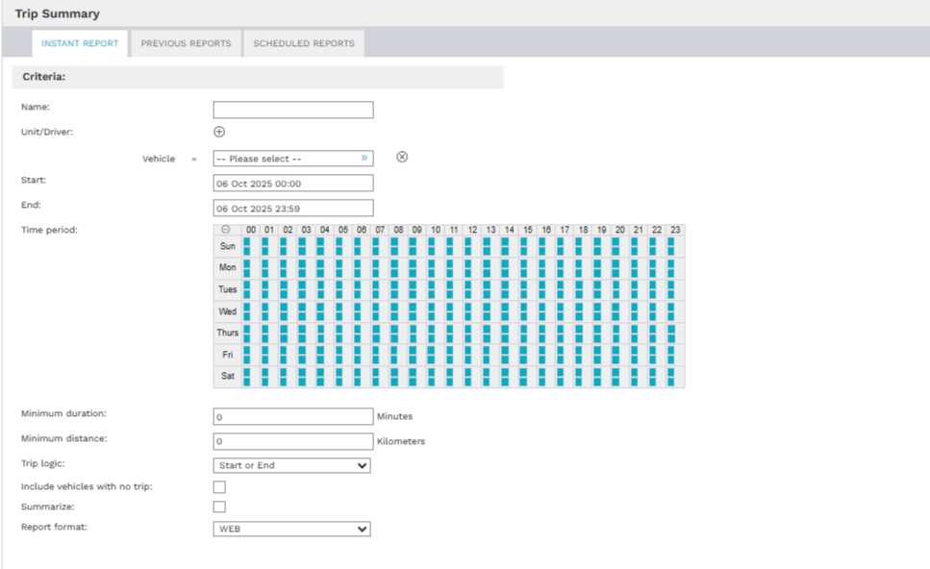

- Click OK to generate the report

Your report will be instantly created and will appear under the Previous Reports tab.

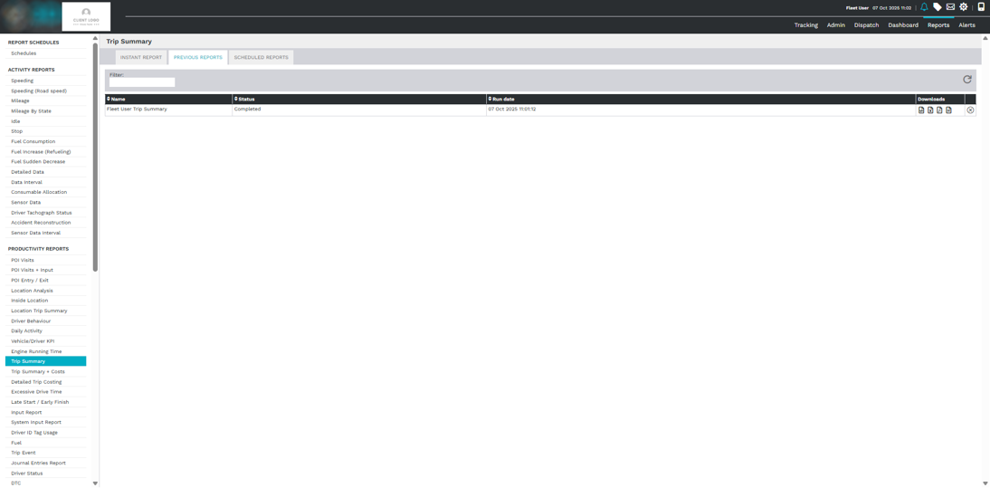

From here, you can:
- Check the Status
- See the Run Date
- Download the report in your preferred format

Scheduled Reports

Scheduled Reports allow you to automate reporting—ideal for recurring tasks like weekly summaries or monthly fuel tracking.

Steps to Create a Scheduled Report:
- In the Scheduled Reports tab, click the plus (+) button to add a new schedule

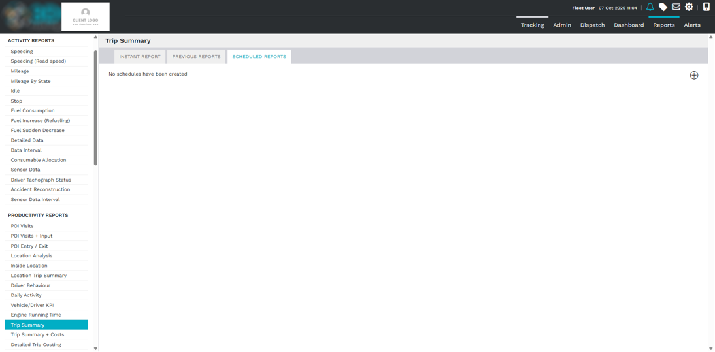

- Fill in the following fields:
  - Report Name
  - Vehicle or group selection
  - Date Range
  - Duration & Distance filters

You’ll also see new fields specific to scheduled reports.

Additional Scheduling Options

Send To:
Choose who should receive the report. You can send it to:
- Individual users
- User groups
- Specific drivers

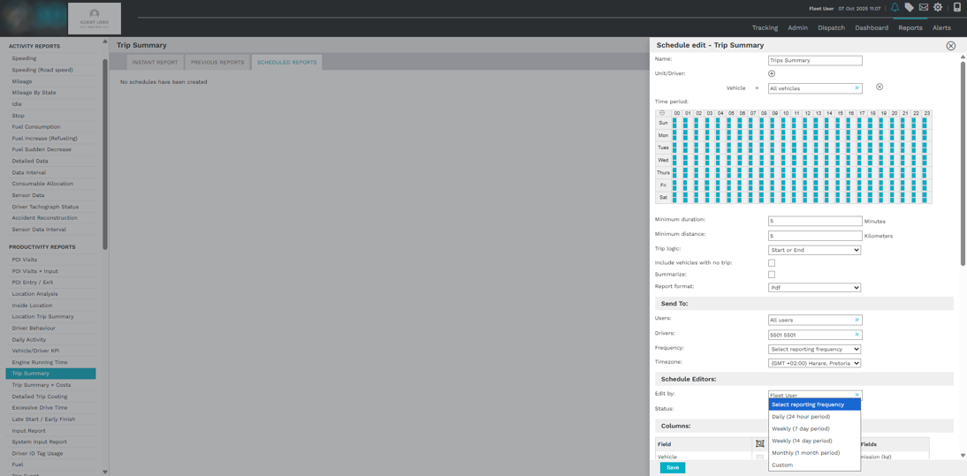

Frequency:
Decide how often the report is sent:
- Daily
- Weekly
- Monthly
- Custom (specific intervals)

Set the Time Zone to ensure the report runs at the correct time.

Final Scheduling Fields
- Schedule Editor: Assign users who can edit the report schedule
- Status: Set the schedule as active or suspended
- Columns: Choose which data columns appear in the report

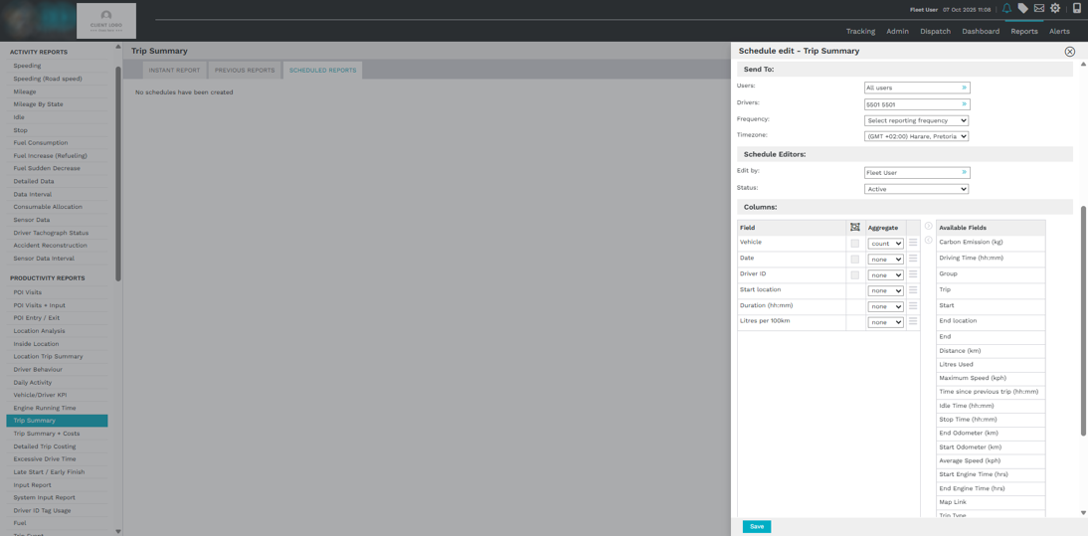
Once you're done, click Save.

Viewing Scheduled Reports

After saving, your scheduled report appears in the summary list with key info:
- Report Name
- Type
- Owner
- Frequency
- Last Sent Date
- Next Scheduled Date
- Status

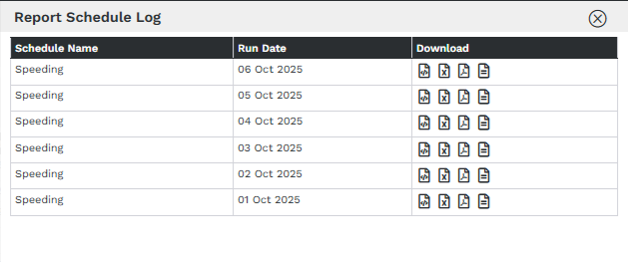

You’ll also see a log of previously run scheduled reports.
If you ever need to make changes, just click on the report to edit its settings.

