Tutorial:
Location Management Guide
Creating and Managing
POIs, Geofences, and No-Go-Zones

Creating and Managing POIs, Geofences, and No-Go Zones

The tracking platform makes it easy to define, organize, and manage locations—whether you're monitoring a few key points or overseeing a full-scale fleet operation. This guide covers how to create circular and custom-shaped locations, manage them centrally, and import them in bulk.

Part 1: Creating Locations from the Tracking Tab

You can create locations directly on the live map using the Map Tools panel in the Tracking tab.

To create a circular location:

- Open the Map Tools panel.
- Select the Draw a Circle tool.
- Click and drag on the map to define the area.
- Once released, the Create Location window will appear.

Here, you can:

- Choose a Location Type:
  - Point of Interest (POI).
  - Geofence.
  - No-Go Zone.
- Customize settings:
  - Size, icon, color, opacity.
  - Assign to a location group.
  - Give your location a clear, descriptive Name.

Click Save to complete the process.

To create a custom-shaped location:
- Select the Draw a Shape tool.
- Click to set points and outline the area.
- When the shape closes, the Create Location window will reappear.
- Name your location, assign a type, and set your preferences.

Click Save. This method gives you more control over irregular zones and boundaries.

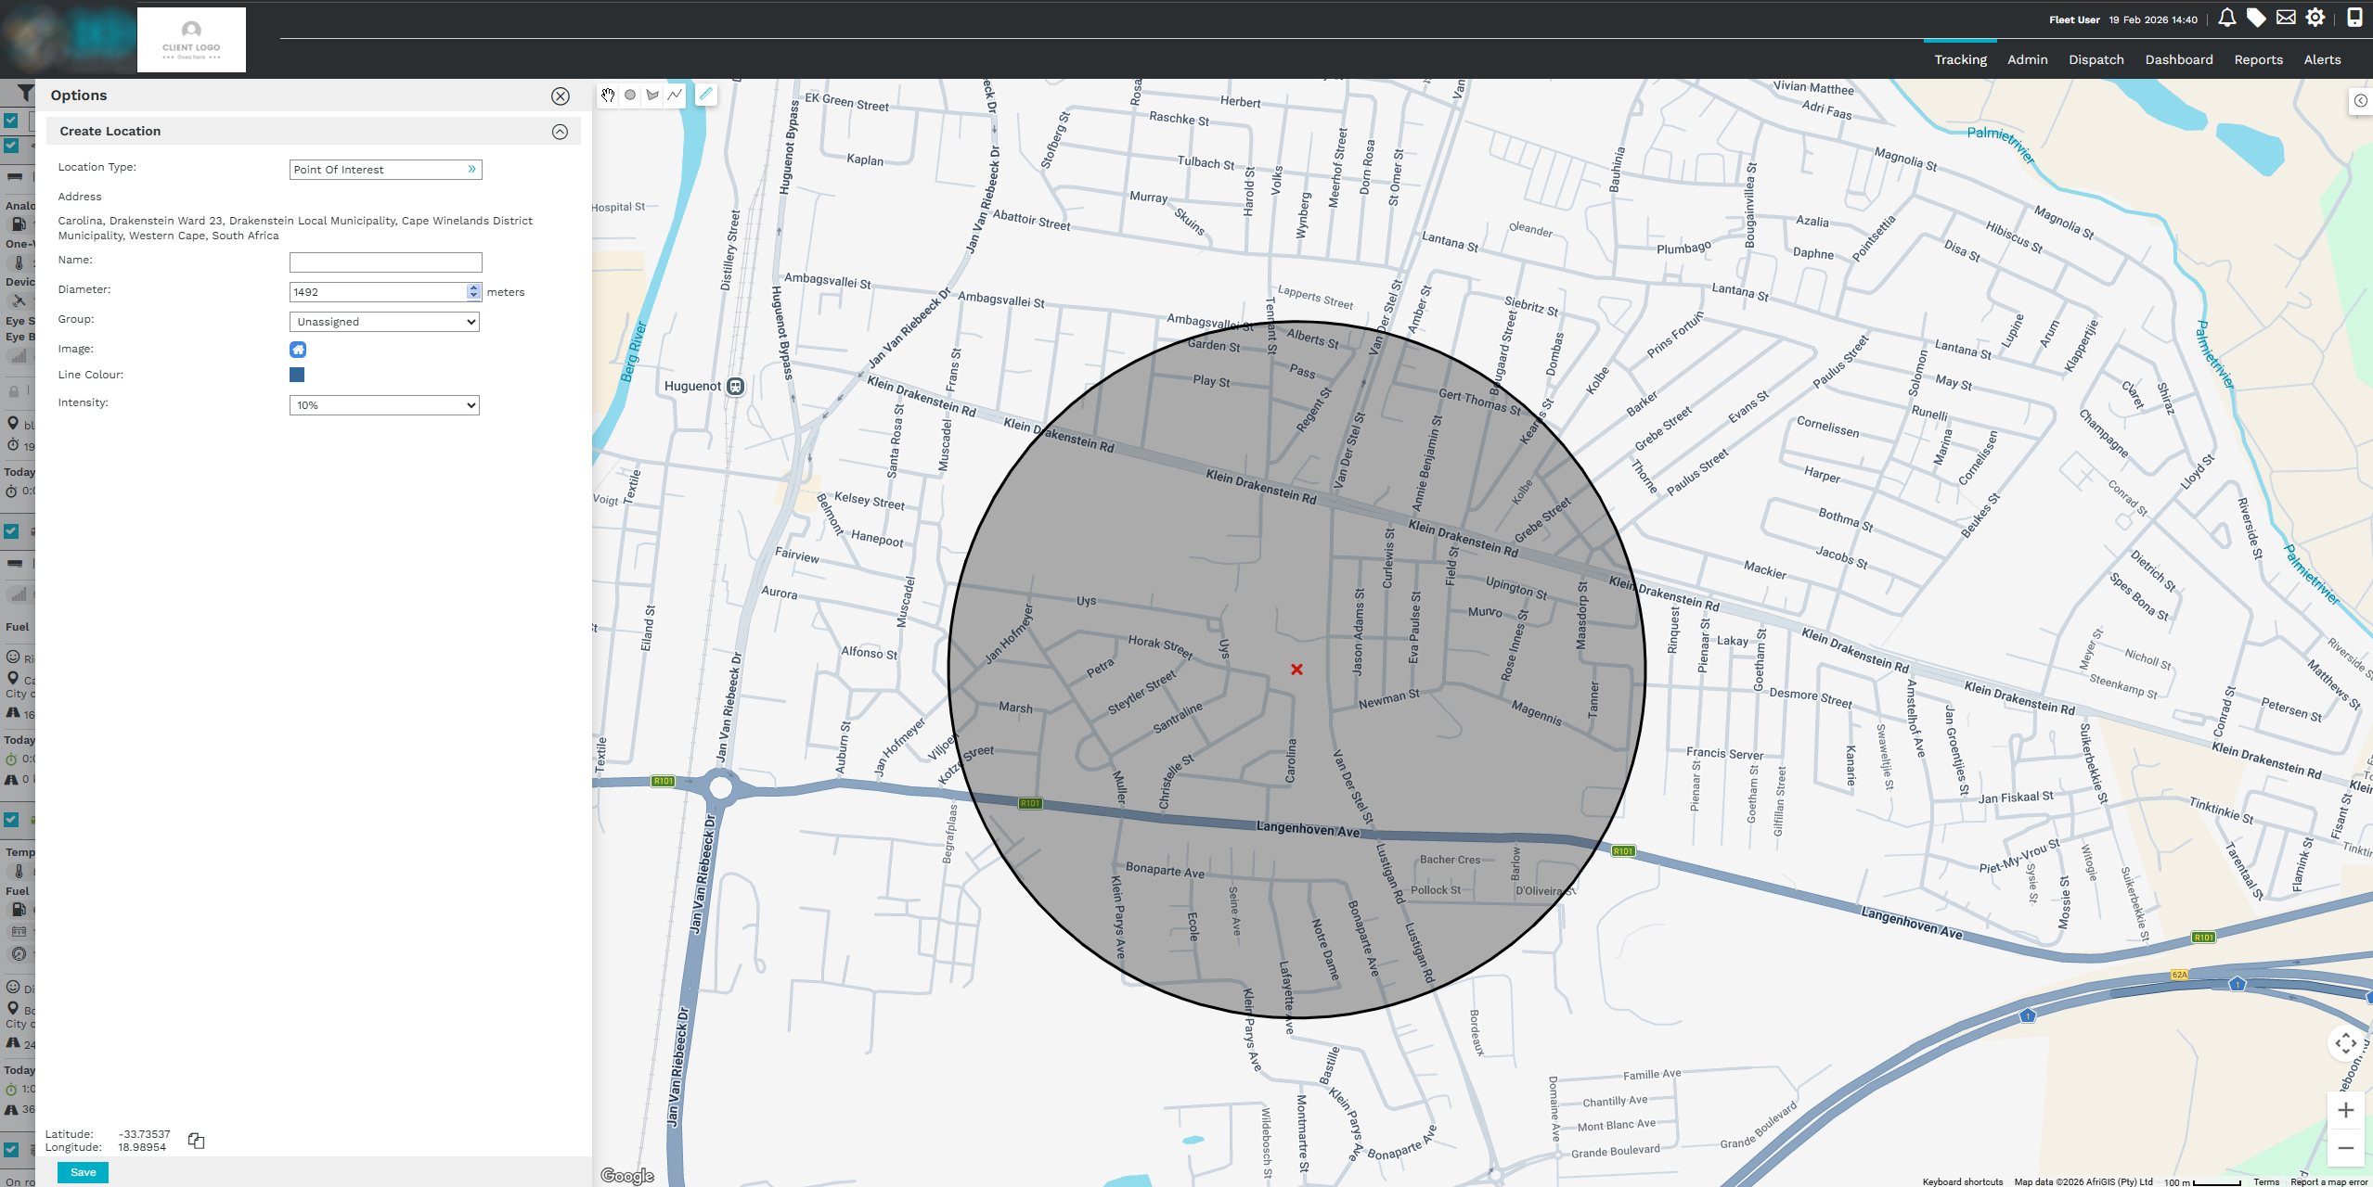
Part 2: Managing Locations from the Admin Tab

For a centralized view and management of all locations:

- Navigate to the Admin tab and select Location Management.
- You’ll see a full list of all POIs, geofences, and no-go zones created within your account.

Each entry includes:
- Name.
- Type.
- Assigned group.
- Address.
- Date created .

You can:
- Use filters to search by name or type.
- Download all locations as a KMZ file (compatible with Google Earth).
- Organize entries using the Groups tab for better filtering and reporting.
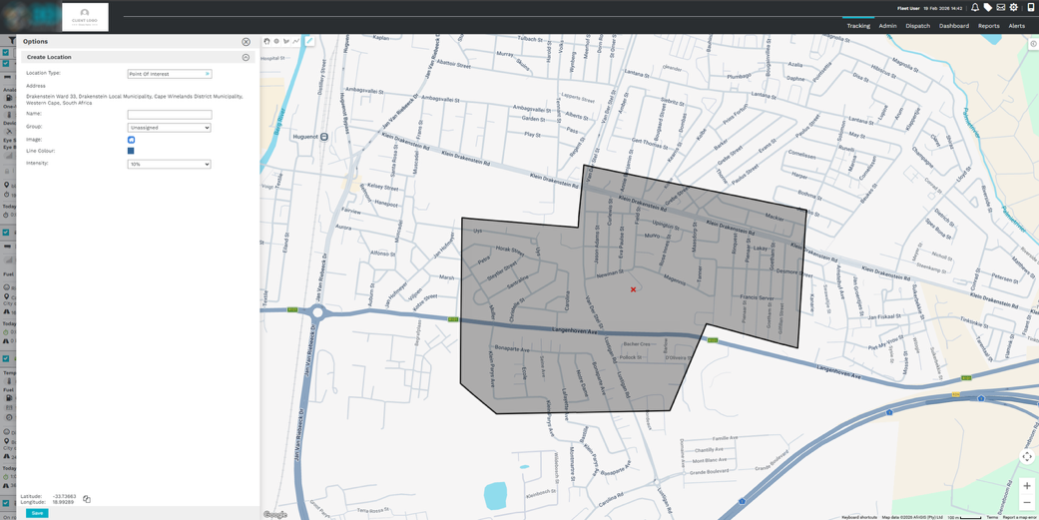
Part 3: Creating Locations from the Admin Panel

You can also manually create locations from within the Admin section.

To add a new location:

- Click the + (plus) button on the right side.
- Choose a type: POI, Geofence, or No-Go Zone.

You can create a location in one of three ways:
- By address.
- By latitude and longitude.
- From an existing POI.

Example – Creating a location by address:

- Type the address into the search field.
- Select the correct suggestion from Google.
- Add a Name, optional Description, and any additional details.

Click Save to create the location.
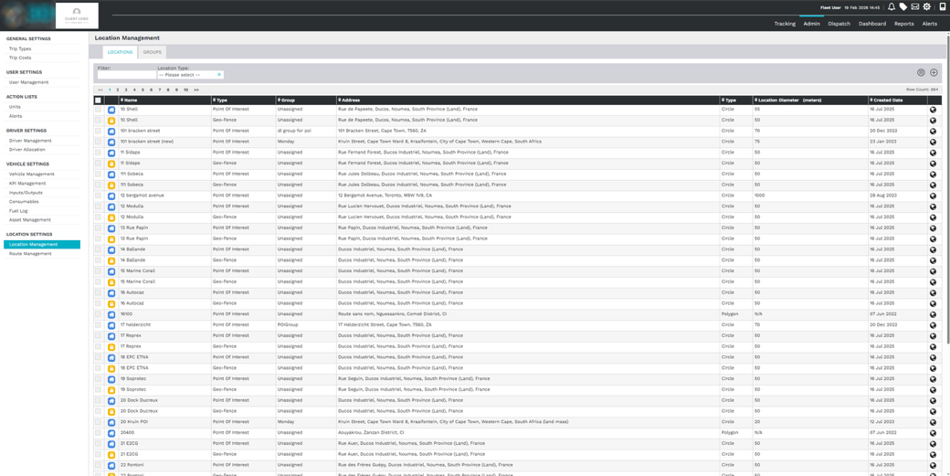

Part 4: Bulk Importing Locations

To save time when importing multiple locations:

- In the Location Management panel, click Import.
- Choose your file format:
  - CSV.
  - GPX.
  - KML.
- Select the location type to import (POI, geofence, no-go zone).
- Upload your file.

You’ll see a preview of the imported data. Click Save to confirm and add all locations to the platform at once.

Summary

The tracking platform provides powerful, flexible tools for managing all types of location data:

- Draw custom zones directly on the map.
- Organize and edit locations from the Admin panel.
- Import hundreds of entries in one go.

