Tutorial:
Navigating the Platform
A walkthrough of the platform’s main navigation features

Navigating the 3Dtracking Platform
This guide provides a walkthrough of the platform’s main navigation features, helping new users confidently explore the system and access key tools to manage fleets efficiently.

1. Landing Page Overview

Once you've logged in using your username and password, you'll be taken to the Landing Page, also known as the Tracking Page. This is your operational home base.

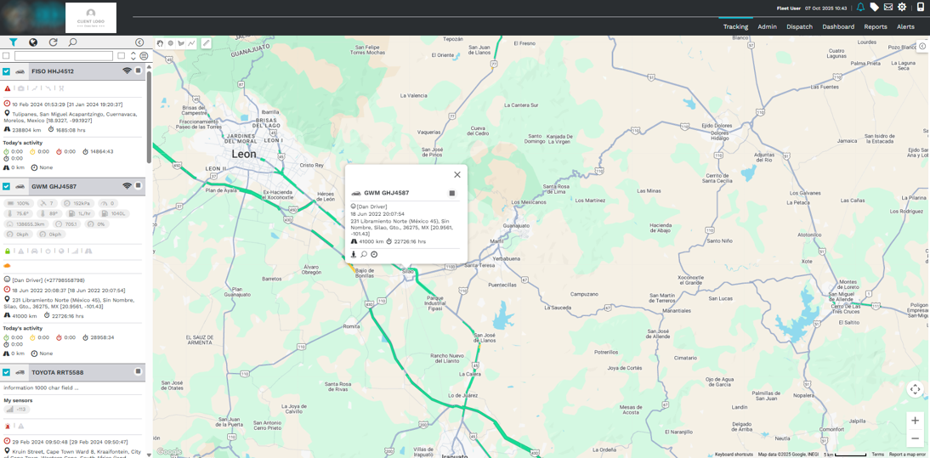

Here’s what you’ll see:
- A real-time map displaying the live location of every vehicle in your fleet
- Key tracking details directly on the map, such as icons, movement status, and heading

2. Unit Listing Panel

On the left-hand side of the screen, you’ll find the Unit Listing panel.

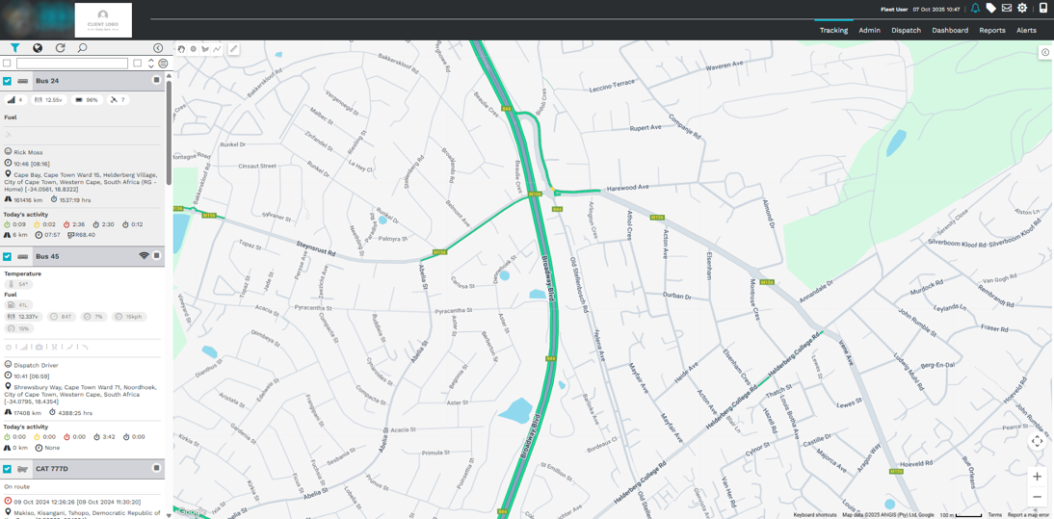
This section displays:
- A list of all vehicles in your fleet
- Key information like sensor data, current status, and last reported activity

You can use the built-in search and filter tools to quickly locate a specific vehicle or group.

3. Navigation Tabs

At the top of the screen, you’ll find several navigation tabs that give you access to different parts of the platform.

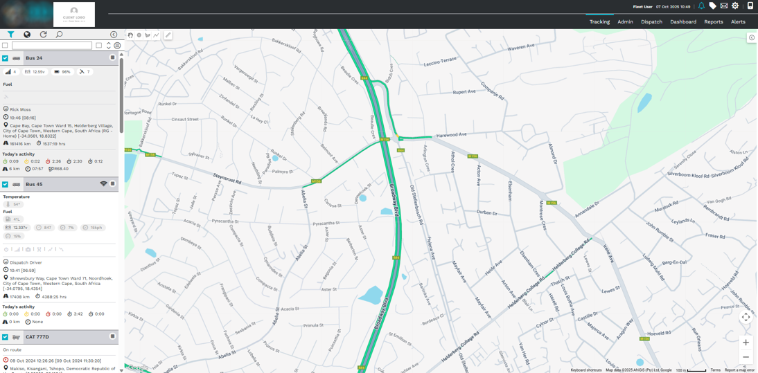

Here’s what each tab does:
- Tracking
The default page where you can monitor vehicles in real time.
- Admin
Access tools for managing users, drivers, vehicles, locations, and groups.
- Dispatch
Handle job assignments, create stops, and manage customer locations.
- Dashboard
Create custom, interactive dashboards using platform data.
Charts can be configured by vehicle groups, timeframes, or data types.
- Reports
Generate and schedule reports to analyze fleet performance over time.
- Alerts
Set up and manage real-time alerts based on specific fleet conditions.

4. Top Right Icons (Quick Access Panel)

In the top-right corner of the platform, you’ll see a row of icons with quick access functions.

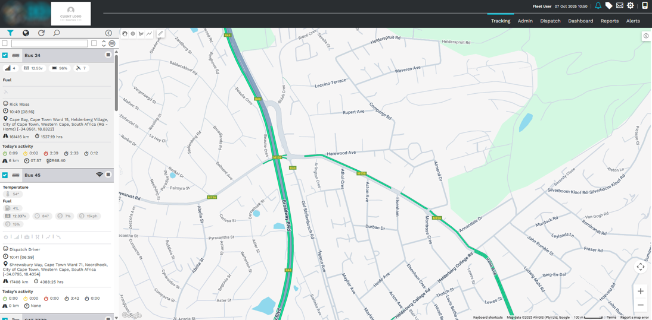
- Alerts Icon
Shows all triggered alerts. You can filter by priority, status, or vehicle.
- Tickets Icon
Internal support system. Raise issues or request assistance directly from here.
- Messages Icon
Stores platform-generated messages like report notifications or system updates.
- Settings Icon
Personalize your experience—change language, region, map views, and date formats.
Also includes access to user preferences and password reset.

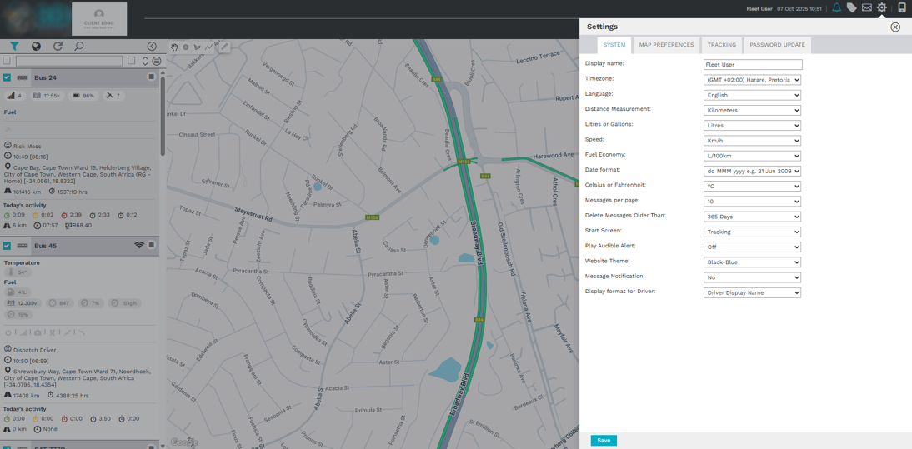

- Switch to Mobile Icon
Quickly switch to the mobile-friendly version of the platform for on-the-go access.

Tips for New Users

- Use the Tracking Page as your base to explore everything
- Don’t forget to customize your Settings early for better usability
- Try using filters and groups to organize your view
- For day-to-day reporting, set up your Dashboard and Reports tabs early

