Tutorial: Creating and managing sudden decrease alerts

Creating and managing sudden decrease alerts
Sudden decrease alerts notify you when a vehicle's fuel level drops by a specified amount within a defined period. By configuring alert conditions, you can monitor unexpected fuel changes and receive notifications when a sudden decrease occurs.
This helps fleet managers:
- Monitor sudden drops in vehicle fuel levels.
- Receive notifications when configured thresholds are met.
- Monitor fuel changes while vehicles are stationary or moving.
- Improve visibility of unexpected fuel activity.
Creating a sudden decrease alert
To create a new alert:
- Navigate to the Alerts tab.
- Select Fuel Level - Sudden Decrease from the Alerts list.
- Click the + button to create a new alert.
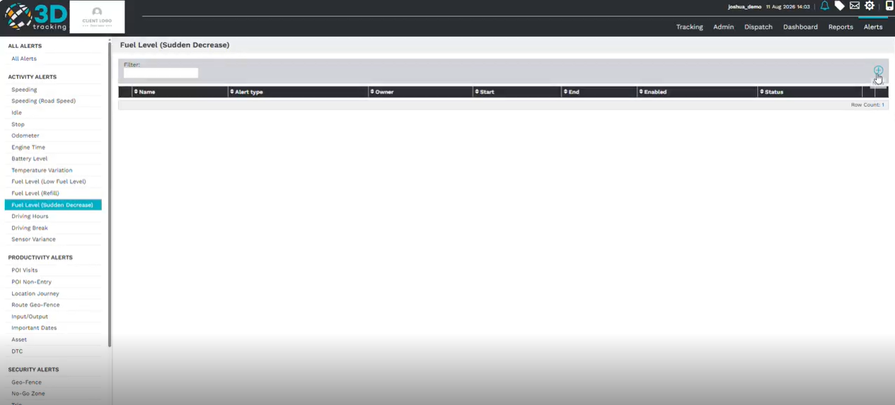

Configure the alert details
Complete the required alert information:
- Enter a descriptive Alert Name.
- Select the vehicle or vehicles the alert should apply to.
- Select the appropriate fuel sensor.
Next, configure the parameters that determine when the alert should trigger.
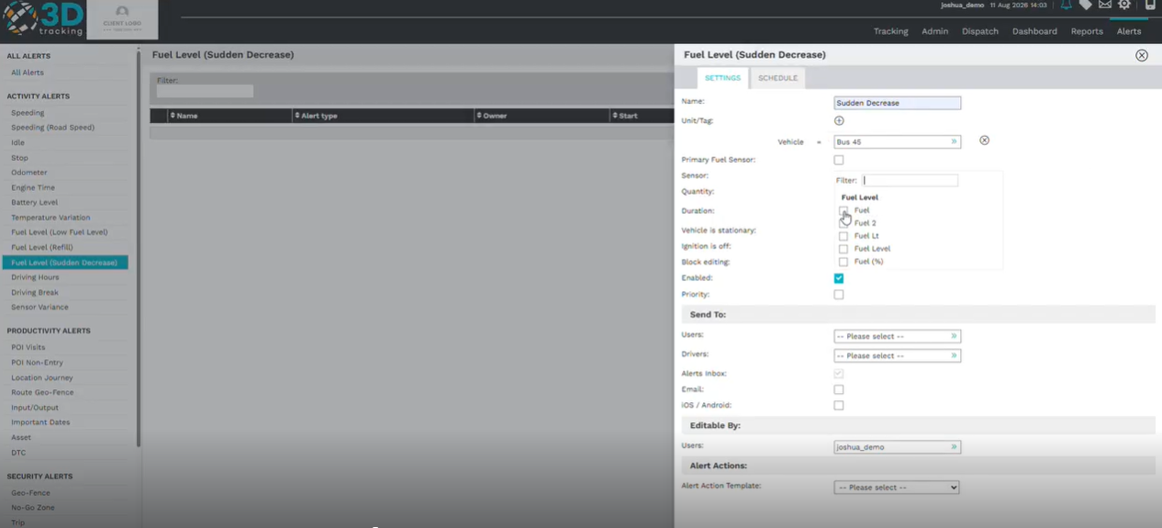
Configure alert conditions
Define when the alert should trigger by configuring the required conditions.
Set:
- The fuel quantity decrease.
- The duration for which the decrease occurs.
- The vehicle status, such as stationary or moving.
- The ignition status, such as on or off.
- For example, you can configure the alert to trigger when the fuel level decreases by 20 liters within 5 minutes.
These settings determine the conditions that must be met before the alert is sent.
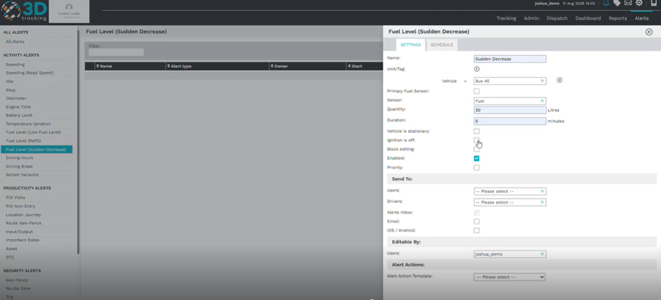
Configure alert notifications
Choose who should receive the alert when a sudden decrease event occurs.
Configure:
- Platform users.
- Notification delivery method.

Notifications can be sent via:
- Email.
- iOS mobile application.
- Select the required recipients and notification methods before continuing.

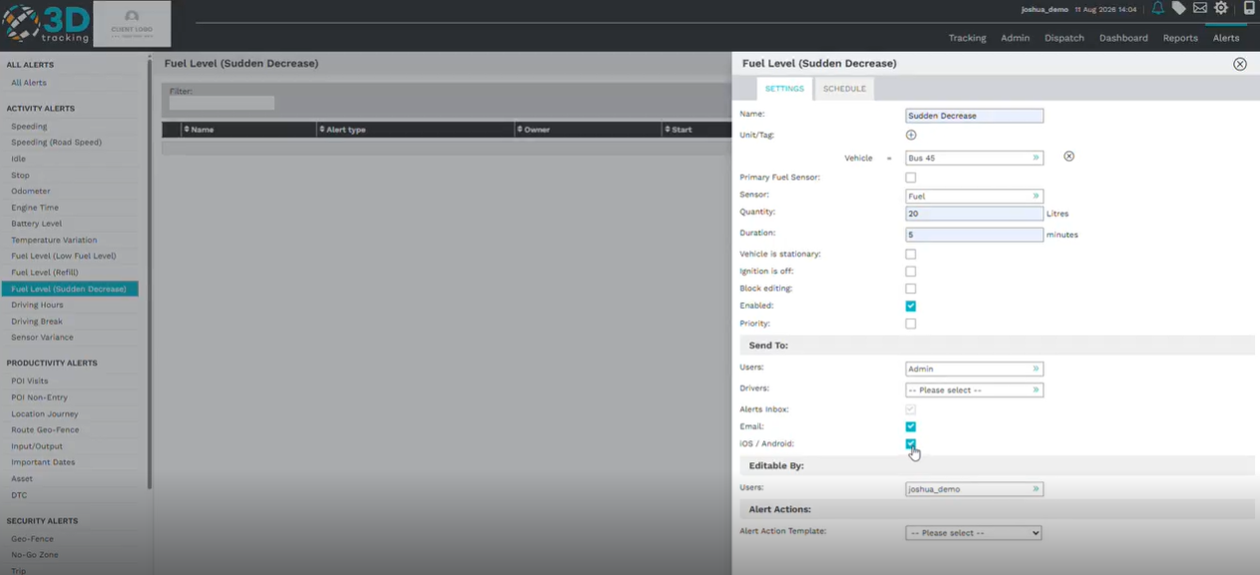
Schedule the alert
The schedule allows you to define when the alert should be active.
- Select the days and times during which the alert should trigger. To receive the alert at any time, ensure all required time periods are selected.
- Review the schedule before saving.
Once the schedule has been configured, review the alert settings before saving.
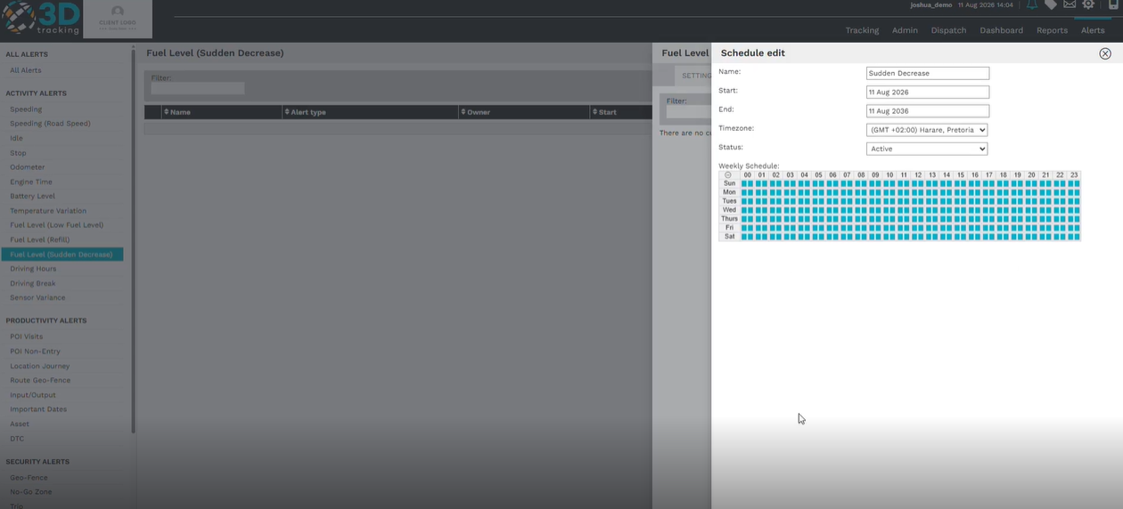

Saving the alert
After reviewing the alert configuration, click Save to activate the alert.
Once saved, the platform will notify selected recipients whenever the configured sudden decrease conditions are met.
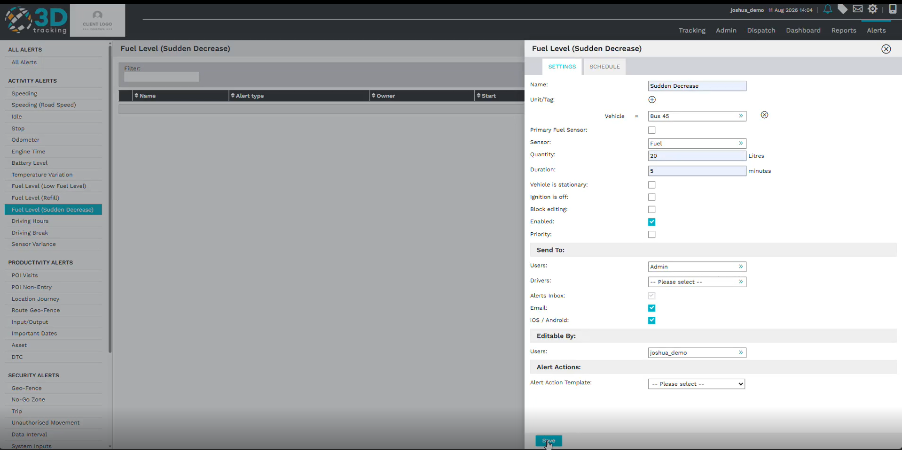
Summary
With 3Dtracking's sudden decrease alert functionality, you can:
- Monitor sudden decreases in vehicle fuel levels.
- Configure alerts using quantity and duration parameters.
- Apply vehicle and ignition status conditions.
- Notify selected users when the configured conditions are met.

